Interactions Between Asphaltenes and Model Demulsifiers in Bulk and at an Interface Studied by Small-angle Neutron Scattering (SANS) and Neutron Reflectometry

Kenneth D. Knudsen,†,∥ Sébastien Simon,*,⊥ Thomas Geue#, Jos F. K. Cooper‡, Johan Sjöblom⊥

†Institute for Energy Technology (IFE), N-2007 Kjeller, Norway
∥Department of Physics, the Norwegian University of Science and Technology (NTNU), N-7491 Trondheim, Norway
⊥Ugelstad Laboratory, Department of Chemical Engineering, the Norwegian University of Science and Technology (NTNU), N-7491 Trondheim, Norway
# Laboratory for Neutron Scattering and Imaging (LNS), Paul Scherrer Institute, CH-5232 Villigen PSI, Switzerland
‡ ISIS Neutron and Muon Source, Science and Technology Facilities Council, Rutherford Appleton Laboratory, Harwell Science and Innovation Campus, Oxon OX11 0QX, United Kingdom

KEYWORDS: Asphaltenes, Demulsification, SANS, Neutron Reflectometry

ABSTRACT: This article describes different neutron techniques to probe the interactions between asphaltenes and model demulsifiers and the structure of the asphaltene layer adsorbed onto a hydrophilic silicon surface.
To start with, asphaltene nanoaggregation is studied in bulk. In pure toluene, asphaltenes form nanoaggregates. Their sizes moderately increase when heptane is added. The presence of 4-Dodecyl benzene sulfonic acid (DBSA), used as a model demulsifier, induces an increase of the size of asphaltene nanoaggregates at model DBSA content followed by a decrease if the concentration of DBSA is increased. These evolutions mean that DBSA can be incorporated into the surface of asphaltene aggregate when its content is moderate, and when the DBSA content increases, a disruption of aggregates occurs, perhaps by peptization. In the second part of the article, the structures of asphaltenes, pluronic – another model demulsifier, and a mixture of them adsorbed onto silicon wafers were determined by neutron reflectometry. It is first shown that meaningful results on the structure of the adsorbed asphaltene layer can only be determined by measuring reflectivity curves in various mixtures of D- and H-toluene. The asphaltene layer has a thickness of 51 Å and its solvation increases with distance from the silicon oxide layer, reaching finally a value of 91 %. In presence of pluronic, the layer does not protrude as far in the bulk (thickness is reduced) and becomes more compact (lower average solvation) due to the incorporation of pluronic.

INTRODUCTION
The production of crude oil is associated with the co-production of important amounts of water. Indeed, in 2009 on a world-basis, 250 million barrels of water was co-produced (water cut ca. 70 %) along with the 80 million barrels of crude oil/day ¹. This water is generally present as water-in-oil (w/o) emulsions. These emulsions need to be processed to obtain oil containing less than 0.5 % of water to be exported and water with a concentration of oil in the water phase lower than 30 ppm to be discharged. The oil-water separation process is based on gravity difference between oil and water. It takes place in multi-stage gravity separators, which allows the sedimentation and the coalescence of water droplets. Various strategies can be implemented to speed up the separation: heating to reduce the viscosity of the oil phase and improving coalescence by either implementing electric fields (electrocoalescence²⁻⁴) and/or adding cocktails of chemicals named demulsifiers⁵.
Crude oil emulsions are stabilized by various crude oil components⁶ namely asphaltenes^{7, 8}, naphthenic acids⁹⁻¹¹, and resins, and, also, by inorganic particles¹²⁻¹⁴ (Pickering emulsions). Asphaltenes are the most polar compounds present in crude oil. They are defined as the fraction of oil insoluble in n-alkane such as n-pentane, n-hexane, and n-heptane, and soluble in aromatic solvents such as toluene or xylene^{6, 15}. Asphaltenes are mixtures of molecules differing in molecular weight and chemical structure^{16, 17}. Fluorescence depolarization techniques¹⁸⁻²¹, subsequently confirmed by mass spectrometry²²⁻²⁴, has shown that typical mean molecular weights of asphaltenes are ca. 750 g·mol⁻¹ with a factor of two in the width of the molecular weight distribution. Asphaltenes include significant amounts of heteroatoms (nitrogen, oxygen, and sulphur) and metals, the most abundant being iron, nickel, and vanadium. The presence of heteroatoms make the asphaltenes relatively polar with the presence of functional groups like pyridine or pyrrole in the case of nitrogen^{25, 26}, and carboxylic acid, phenol, or ketone for oxygen²⁷. It has also been shown that asphaltenes are polyaromatic. Based on all the structural characterization results, different models have been suggested to represent an “average” asphaltene molecule: the archipelago and the continental models²⁸. The latest published results, for instance the direct visualization of asphaltene molecules by atomic force microscopy (AFM) and molecular orbital imaging using scanning tunnelling microscopy (STM) ²⁹, seem to point towards the second³⁰. In the continental model, asphaltenes are composed of a single polyaromatic ring with aliphatic and/or naphthenic substituents.
Asphaltenes are prompt to self-associate in bulk both in model solvent or in crude oil. Two scales have two be considered³¹. First, in good solvent conditions, asphaltenes form nanometre-sized aggregates, subsequently referred to as nanoaggregates, that are stable in time. If the solvent conditions get worse (by addition of a precipitant like an alkane for instance) and the precipitation onset is reached, asphaltenes start to flocculate to form micrometre-sized flocs^{32, 33}. Different models have been proposed to describe the asphaltene nanoaggregation: The Yen model³⁴ and its updated version: The Yen-Mullins model^{30, 35}, the Peptization model by Pfeiffer et al.³⁶, and the application of fractal concepts^{37, 38}. In the Yen-Mullins model^{30, 35}, ca. six asphaltene molecules self-associate to form nanoaggregates by π–π stacking of their polyaromatic parts. At higher concentrations, nanoaggregates form clusters again with small aggregation numbers. The aggregation extent seem to be a trade-off between attractive interactions (π–π stacking, Hydrogen bonds³⁹…) and repulsions due to steric hindrance by aliphatic chains^{40, 41}.
The structure of the asphaltene layer on water droplets have been studied by Small-Angle Neutron Scattering using model systems by Jestin et al.⁴² and Verruto and Kilpatrick⁴³. These authors have managed to determine the values of the following parameters: Adsorbed amount at interface ≈ 2 mg/m², volume fraction of asphaltenes in adsorbed layer ≈ 10 – 30 %, and thickness adsorbed layer ≈10-15 nanometers.
Demulsifiers are molecules designed to increase the oil-water separation rate⁵. They entail a large variety of chemical structures ranked in 10 different chemical classes by Kelland⁴⁴. However, this author notes that most of the demulsifiers are non-ionic polymers with molecular weight generally varying in the 2000-5000 g/mol range, even if some demulsifiers can be much bigger. Moreover, generally demulsifiers contain polyalkoxylate chains like ethylene oxide (EO) and propylene oxide (PPO). Demulsifiers are generally injected at a dosage of a few tens of ppm in production facilities. The choice of the demulsifier for a specific oil field is still based on trial and error involving multiple bottle tests.
In order to obtain better knowledge about the mechanism of demulsification, the interactions between asphaltenes and model demulsifiers (dodecylbenzene sulphonic acid - DBSA – and pluronic PE 8100) were studied in two media: i) In bulk. The size of asphaltene aggregates dissolved in model organic solvents with and without model demulsifiers were measured and compared by Small-Angle Neutron Scattering (SANS). ii) At interfaces. Asphaltenes at the silica/toluene surface were studied by neutron reflectometry (NR) in order to mimic the water-oil interface present in crude oil emulsions.

EXPERIMENTAL SECTION

Chemicals
Asphaltenes were obtained by precipitation from a Norwegian heavy crude oil. Briefly, n-hexane was added to the crude oil at a ratio of 40 mL hexane/g crude oil and stirred overnight. Then the asphaltene was recovered after filtration using a 0.45 µm HVLP (Millipore) membrane filter and dryed in a nitrogen environment. The elemental composition of asphaltenes obtained from the same crude oil and the same procedure is presented in Subramanian et al.¹⁷
4-Dodecyl benzene sulfonic acid (DBSA, mixture of isomers, purity ≥ 95%) was obtained from Sigma-Aldrich. Pluronic PE 8100 was obtained from BASF. This is a triblock copolymer PEO_{x}-PPO_{y}-PEO_{z} with a molecular weight of ca. 2600 g/mol and 10 % PEO groups⁴⁵.
Silicon wafers were obtained from two different providers: The experiments at Paul Scherrer Institute were performed using silicon wafers from SPM AG (Liechtenstein) of dimensions 100 x 50 x 10mm (DSP < 10 Å). The silicon wafer used at the Rutherford Appleton Laboratory was from Crystran Limited (UK). It is a Silicon block (111) of N-type of dimensions 80 x 50 x 15 mm (Surface roughness, Ra < 4 Å).
Silica QSX 303 crystals from Biolin Scientific were used for QCM experiments.
Deuterated toluene (≥ 99.6 atom % D) was from Sigma-Aldrich while deuterated heptane was from Chiron (Norway).

Preparation of Solutions and Surfaces
Asphaltene solutions were prepared by dissolving solid asphaltenes in deuterated and hydrogenated toluene. The solutions were then sonicated for half an hour and shaken overnight. Finally, the asphaltene solutions were mixed with heptane, toluene, pluronic solutions in toluene, or DBSA solutions in toluene to the desired mixture compositions.
Pluronic solutions were initially prepared in toluene before being mixed to the desired composition. The same procedure was used to prepare DBSA solutions.
The silicon wafers and QCM crystals were chemically treated before use to obtain a well-defined oxide layer at their surface with the following treatment⁴⁶. First, the wafers were thoroughly rinsed with Milli-Q water (Millipore) and treated with a solution composed of ammonia (30 % solution), hydrogen peroxide (30% solution) and Milli-Q water (volume ratio 1:1:5) at 75°C for 15 minutes. The crystals were then thoroughly rinsed with Milli-Q water and dried. For wafers that had already been used previously (except QCM crystals), they were first washed with H-toluene and acetone and dried out before being treated with NH₃/H₂O₂/H₂O.

Small-Angle Neutron Scattering (SANS)
SANS measurements were used to determine the size of asphaltene aggregates. It is a technique that has also been applied before to characterize asphaltene samples (size, molecular weight, shape⁴⁷⁻⁴⁹).
The SANS measurements were performed at the IFE facilities in Kjeller, Norway using the JEEP-II reactor. The samples were introduced in 2 mm Starna quartz cells and mounted in copper holders, keeping the temperature constant at 23 °C. Two different detector distances were employed (1.0/3.4 m), as well as two different wavelengths (5.1/10.2 Å) in order to obtain a wide Q-range. Here Q is given as Q=(4π/λ)sinθ with λ being the the neutron wavelength and 2θ the scattering angle. The transmission was measured separately and the absolute scattering cross section I(Q)(cm⁻¹) of the samples was calculated by subtracting the contribution from empty cell, solvent (mixture of deuterated heptane and toluene, same composition as the analysed sample) and general background.

Neutron Reflectometry
Neutron reflectometry experiments were performed in two different neutron institutes: At the Paul Scherrer Institute-PSI (Switzerland) and at the Rutherford Appleton Laboratory-RAL (UK).
The purpose of the experiments, the experimental procedures, and the analysis of the experiments performed at the two institutes being different, they are presented separately. At PSI the experiments were performed on the AMOR reflectometer⁵⁰. A cleaned wafer was installed into the cell and up to 25 mL of solution to be analysed was introduced. After plugging both ends of the flow line, the cell was installed in the reflectometer and aligned with the neutron beam. The measurements started 10 to 15 minutes after introduction of the solution. The temperature was kept constant at 23°C. At RAL the experiments were performed on the Offspec neutron reflectometer at the ​​​​​​​​​​​​​​​​​​​​​​​​​​​​​​​​​​​​​​​​​​​​​​​​​​​​​​​​​​​​​​​​​​​​​ISIS Neutron and Muon Source. Only one silicon wafer was used in the entire campaign and the alignment was only carried out one time with the cell filled with D-toluene. The measurements were performed by replacing the asphaltene solution previously in the cell by flowing 17 mL of a new asphaltene solution at the same concentration (2 g/L) with a different D-toluene/H-toluene ratio to vary the contrast. The last 3 mL exchanged was recovered and its density measured at 20°C by an Anton Paar DMA 4100 densitometer to make sure that the exchange was complete. The reflected intensity was measured at three angles (0.5, 1.3, and 2°) using a wavelength band of 1-14 Å.
The analysis was performed by means of the Motofit routines⁵¹ implemented into the IGOR programming environment⁵², as well as the GenX software⁵³. The latter was particularly useful for linking several coupled parameters during the contrast variation series. The appropriate dq/q-resolution given by the experimental setup was entered for each case in order to properly account for instrumental broadening. The Levenberg–Marquardt algorithm (Motofit) and the so-called differential evolution algorithm (GenX) were employed in the least-square analysis, and in all cases the χ²-values were followed to ensure convergence.

Quartz Crystal Microbalance (QCM)
Extra experiments were performed by QCM to determine the adsorbed amount of asphaltenes, pluronic, and mixture of asphaltenes + pluronic.
Experiments were performed using the single sensor microbalance system Q-sense E1 from Biolin Scientific at 20°C. First, pure toluene was injected until a stable baseline was obtained. The solution to analyse was then injected into the chamber and left to rest for 1 hour. A desorption study was done by subsequently injecting pure toluene. The QCM apparatus measures the variation of the oscillation frequency $Δf$ due to the adsorption for various overtone numbers n. The adsorbed amount Γ was calculated using the Sauerbrey equation⁵⁴:
$∆Γ=-\frac{ρ_{q}t_{q}}{f_{0}n}Δf=-\frac{ρ_{q}υ_{q}}{2{f_{0}}^{2}n}Δf=-\frac{C}{n}Δf$ (1)
where $ρ_{q}$ (=2648 kg/m3) and $t_{q}$ (=0.3 mm) are the mass density and thickness of the crystal, $υ_{q}$ (=3340 m/s) is the shear wave velocity in quartz, $f_{0}$ (= 5 MHz) is the fundamental frequency of the crystal. The constant C equals 0.177 mg/m²Hz.

RESULTS AND DISCUSSION

Bulk Interaction Studied by SANS
In bulk, asphaltenes form nanoaggregate in good solvents like toluene or xylene. Due to the opacity of the solution, light scattering methods are not ideal and this nanoaggregation has therefore been studied by Small-Angle X-Ray Scattering (SAXS) and Small-Angle Neutron Scattering (SANS). Size and molecular weight of nanoaggregates have been determined by analysing scattering curves at low scattering vector Q using equations that do not assume any particular shape of the asphaltene nanoaggregates (Guinier or Zimm equation) or by fitting the entire curve assuming a shape of spheres, or oblate or prolate cylinders. In spite of the diversity of analysis methods, most SAXS and SANS studies converge on nanoaggregate sizes between ca. 2 and 10 nm depending on the origin of the asphaltenes, the nature of the solvent, and the temperature^{37, 38, 47-49, 55-59}.
In this section, the interactions between asphaltenes and a model inhibitor (DBSA) are investigated. To fulfil this goal, the selected strategy consists in determining the effect of DBSA on nanoaggregate size of asphaltenes in different solvent condition using SANS. All the solvents are deuterated to maximize the contrast factor between asphaltenes and the solvents and reduce the incoherent scattering.

Nanoaggregation of Asphaltenes

Nanoaggregation in Pure D-Toluene
This section presents the result of the characterization of nanoaggregates formed in solution by asphaltenes in good solvent (d-toluene) in absence of DBSA.
Figure 1 shows the scattering pattern of a solution of 10 g/L asphaltenes in d-toluene. This concentration was chosen to obtain a good signal to noise ratio. The pattern is typical of the scattering of asphaltene nanoaggregates ^{47, 59} with a plateau at low Q and a decrease of the intensity at higher q-values. Two methods were used to calculate the size of asphaltene nanoaggregates: First the Guinier fit (equation 1) valid at low Q (Q×Rg < 1) allows to determine the radius of gyration Rg by plotting Ln I(Q)as a function of Q². This method is independent of the shape of asphaltene nanoaggregates.
$I\left(q\right)=I_{0}∙exp\left(-\frac{{Rg}^{2}}{3}∙Q^{2}\right)$ (2)

Here Q is is the absolute value of the scattering vector as defined previously.
Secondly, the entire scattering pattern was fitted with a disk model (flat cylinder) as defined in equation 2⁶⁰. P(Q) is the form factor which at low concentrations is proportional to the intensity.

$$P\left(q\right)=\frac{scale}{V}\int_{0}^{\frac{π}{2}}{F^{2}\left(Q,α\right)\sin{α}dα+background}$$
(3)

where F²(Q,α) is the average squared value of the scattering amplitude, given by

$$F\left(Q,α\right)=2\left(∆ρ\right)V\frac{\sin\left(\frac{1}{2}QL\cos{α}\right)}{\frac{1}{2}QL\cos{α}}\frac{J_{1}\left(QR\sin{α}\right)}{QR\sin{α}}$$

(4)

Here R is the disk radius, L the disk height and V is the disk volume given by πR²L. The parameter α is the angle between the disk axis and the q-vector.
This model allows to obtain both the radius and the height of the disk. It has for instance been used by Gawrys and Kilpatrick in their studies of asphaltenes^{61, 62}. Figure 1 indicates that the disk models fits well the SANS intensity profile. This does not exclude other possible shapes, for instance it might also be possible to fit these data with nearly equally good results by assuming spherical particles with a broad size distribution, and different shapes have been reported in literature⁴⁷. However, model fitting with this disk model will now allow us to systematically compare the sizes of asphaltene nanoaggregates in different media and in presence of DBSA. In this work, the interaction between aggregates were considered as negligible due to the relatively low asphaltene concentration in solution (2.5 and 10 g/L). This is equivalent to the structure factor being always close to 1.
The radius of gyration, disk radius and height of 2.5 and 10 g/L asphaltene solution in D-xylene determined from the two methods are reported in Table 1. The two methods agree on an asphaltene nanoaggregate radius close to 3 nm, which is typical of values reported in the literature ^{37, 38, 47-49, 55-59}. The size measured at 2.5 g/L is found to be slightly higher than at 10 g/L. However, the signal quality was much lower at 2.5 g/L, leading to larger uncertainties in the estimated radii of gyration. For the same reason, results obtained with the disk model are not reported for the 2.5 g/L samples.

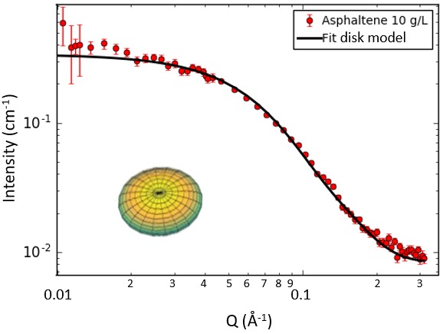 | 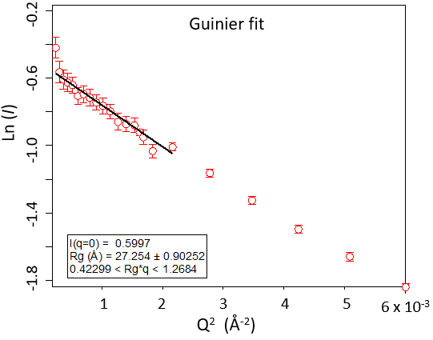

Figure 1. Determination of the nanoaggregation size of asphaltenes. Left: Scattering pattern and the fitting with a disk model. Right: using the Guinier fit Ln I(Q)as a function of Q². System: [Asphaltenes]=10 g/L in D-toluene.

[Asphaltenes] g/L | [DBSA] g/L | Solvent | Guinier  Rg (Å) | Disk model
 |  |  |  | Radius (Å) | Height (Å)
10 | 0 | d-toluene | 28.7 | 31.0 | 20.6
10 | 0 | 25/75 % v/v d-heptane/d-toluene | 28.3 | 31.8 | 21.2
10 | 0 | 50/50 % v/v d-heptane/d-toluene | 35.3 | 39.2 | 21.1
10 | 0.5 | d-toluene | 30.0 | 33.2 | 21.4
10 | 2 | d-toluene | 31.1 | 32.2 | 23.1
10 | 5 | d-toluene | 27.3 | 30.4 | 25.4
2.5 | 0 | d-toluene | 34.3 | u | u
2.5 | 0.5 | d-toluene | 36.0 | u | u
2.5 | 2 | d-toluene | 32.7 | u | u
10 | 2 | 25/75 % v/v d-heptane/d-toluene | 33.7 | 35.2 | 22.7
10 | 2 | 50/50 % v/v d-heptane/d-toluene | 38.6 | 45.3 | 26.3

Table 1. Size of asphaltene nanoaggregates calculated with the Guinier and disk model equations (equations 1 and 2) and measured in various solvents and concentrations and in presence or not of DBSA. u: not reported due to large uncertainties in the disk model.

Influence of Asphaltene Solvency
The size of asphaltene nanoaggregates were determined in different solvency conditions, i.e. by adding various amount of d-heptane but still below the precipitation onset³⁹. The scattering patterns of 10 g/L asphaltenes in d-toluene, and in 25/75 % v/v and 50/50 % v/v d-heptane/d-toluene mixed solvents are presented in figure 2. It can be seen that the scattering pattern is similar in d-toluene and in 25/75 % v/v d-heptane/d-toluene, which means that the nanoaggregates are similar in both media. On the contrary, in presence of 50 % d-heptane, the scattering intensity significantly increases, meaning that the asphaltene nanoaggregates have grown in size. The superimposition of scattered intensity in the high Q region (q>0.1 Å), in pure toluene and in mixture of toluene of heptane, indicates the internal structure of the asphaltene aggregates does not depend on the solvent. The sizes extracted from the scattering patterns and summarized in Table 1 confirm the trend observed in figure 2. Indeed, the radius of gyration of asphaltene nanoaggregates remains constant in presence of 25 % v/v d-heptane (28.7 Å in d-toluene vs. 28.3 Å in 25/75 % v/v d-heptane/d-toluene) and significantly increases in 50 % v/v d-heptane (35.3 Å). However, even if it increases, the radius is still in the nanometre range, thus only moderate additional aggregation takes place. Similar observations can be done with the sizes calculated from the disk model, especially by looking at the radius values. These results are consistent with the observations by Fenistein et al.⁴⁸ and Spiecker et al. (below the precipitation onset)⁵⁷ .

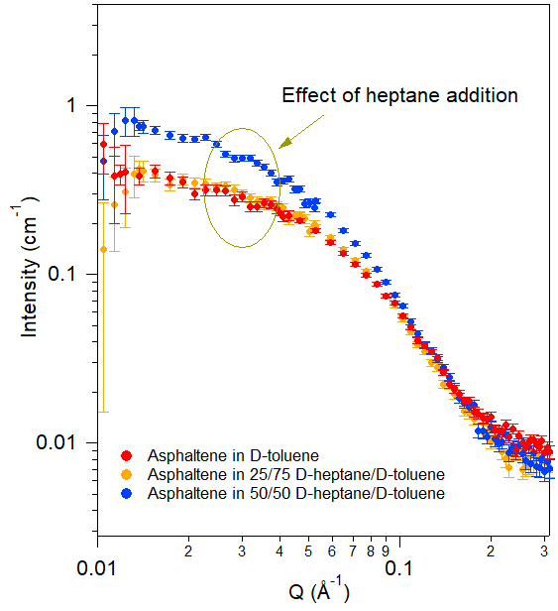

Figure 2. Influence of d-heptane on the scattering pattern of asphaltenes. System: [Asphaltenes]=10 g/L in D-toluene, 25/75 % v/v, and 50/50 % v/v D-heptane/D-toluene mixed solvents. The contribution of solvents has been subtracted from the intensities.

Interactions with DBSA
In this part, the size of asphaltene aggregates in presence of the surfactant 4-Dodecyl benzene sulfonic acid or DBSA was determined. DBSA was chosen as a model demulsifier. It has already been investigated as model compound for studies on asphaltene precipitation and deposition^{63, 64}.
Before studying asphaltene + DBSA systems, scattering patterns of pure DBSA solutions in D-toluene and mixtures of D-toluene and D-heptane were collected. They showed only weak and nearly constant levels due to the incoherent contribution. In the following, the contribution of any DBSA aggregation measured in these blanks experiment has been subtracted from the scattering patterns of asphaltenes + DBSA samples.

Interactions in D-Toluene
Figure 3 presents scattering patterns of asphaltenes + DBSA samples containing increasing concentrations of DBSA. As in previous sections, all the scattering patterns are typical of colloidal systems with a plateau at low Q and a strong decrease of intensity when Q increases. In presence of DBSA, the intensity of the plateau as well as in the intermediate region varies. This is a clear indication of a change taking place in the asphaltene nanoaggregate internal structure in the presence of DBSA.
The size of asphaltene nanoaggregates in presence of DBSA deduced from the scattering patterns in figure 3 are presented in Table 1. The radii of gyration are of the same order of magnitude (around 30 Å) but there is clear evolution with the DBSA content. Below approximately 2 g/L, the asphaltene nanoaggregates grow in size in presence of DBSA. At higher concentration (5 g/L), the nanoaggregates become smaller. These trends indicate that DBSA attaches at the surface of asphaltene aggregates, most likely by complexation. Then when the concentration is high enough at the surface, DBSA can disrupt the link between asphaltene molecules, hindering the aggregation. This is consistent with a peptization mechanism, well-known in the case of resins and asphaltenes since Pfeiffer and Saal³⁶. The observation is also consistent with the results obtained by Chang and Fogler in their study about the stabilization of asphaltenes by DBSA in aliphatic solvent⁶³. In Fig. 3, it may be noticed that the intensity shows a weak upturn in the low-q limit (below Q=0.015 Å⁻¹). This could be due to the presence of a minor population of larger aggregates in the samples. However, these data points have larger error bars, and the size determination is based primarily on the pattern shape in the q-range above 0.015 Å⁻¹. Here one can see that the 5 g/L sample has a slightly different overall shape than the 2 g/L sample, with more of the intensity towards higher q-values (equivalent to smaller sizes).
Similar experiments were performed at lower asphaltene concentration (2.5 g/L) (Table 1). Even if the measurements are less accurate due to the lower signal, it seems that the trends are similar as at higher asphaltene concentrations.

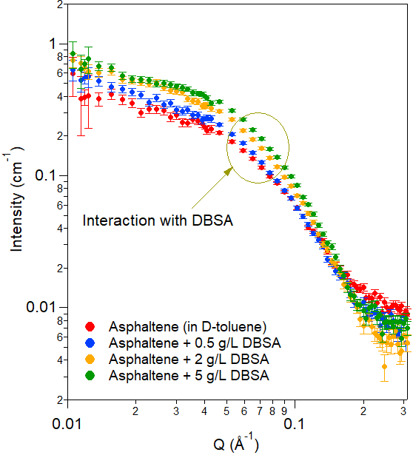

Figure 3. Influence of concentration of DBSA on the scattering pattern of asphaltenes (after subtraction of contribution of DBSA). System: [Asphaltenes]=10 g/L in D-toluene.

Influence of Asphaltene Solvency
The influence of the asphaltene solvency on the interactions between asphaltenes and DBSA was performed by determining the size of asphaltene aggregates in presence and absence of DBSA in solvents containing various contents of D-heptane (figure 4 and Table 1). The asphaltene nanoaggregates become significantly bigger (radius of gyration, or the radius in the case of the disk model) when the heptane content increases, even in presence of DBSA, as was observed in section 3.1.1.2. It can also be noticed that the presence of 2 g/L of DBSA significantly increases the size of asphaltene aggregates, with the radii of gyration being increased between 8 and 19 % depending on the heptane content. This confirms the increase of nanoaggregate size taking place in presence of DBSA at moderate [DBSA]/[Asphaltene] ratio.

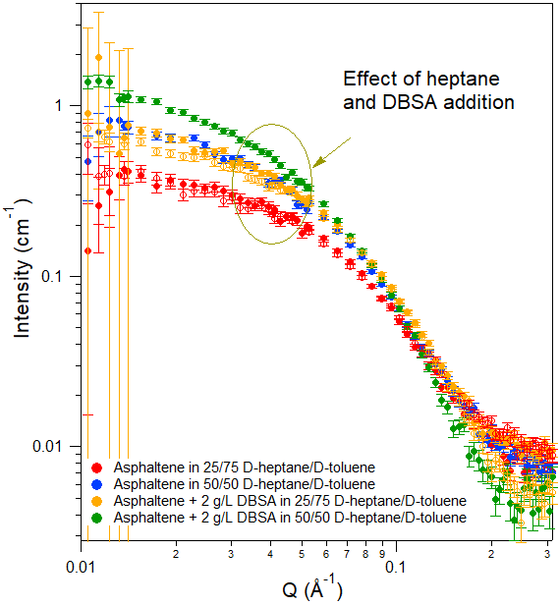
Figure 4. Scattering patterns of asphaltenes with and without DBSA in a mixture of D-heptane and D-toluene (after subtraction of contribution of DBSA). System: [Asphaltenes]=10 g/L, [DBSA]=2 g/L in 25/75 % v/v and 50/50 % v/v D-heptane/D-toluene mixed solvents.

Asphaltene Conformation at Solid Surfaces

Determination of adsorbed amounts using QCM
QCM is a classical technique to characterize adsorption of asphaltenes onto solid surfaces. This technique allows to determine the adsorbed amount, a parameter that is not obtainable from the neutron data with standard data treatment. Therefore, QCM and neutron reflectometry provide results that are complementary.
Table 2 presents the adsorbed mass after 1 h adsorption, Γ_{ads}, and after 30 minutes of desorption in toluene, Γ_{des}. The amount of asphaltene adsorbed onto silica surfaces (3.28 mg/m²) and the desorption (22 %, based on Γ_{des} = 2.56 mg/m²) are typical of values found in the case of adsorption of asphaltenes in good solvent like toluene or xylene onto polar surfaces^{16, 65}. The pluronic adsorbed amount (1.57 mg/m²) is significantly lower than for asphaltenes. The value is also significantly higher than measured by the depletion method on silica particles by Shar et al.⁶⁶ These authors found values between 0.06 and 0.235 mg/m² depending on the pluronic structure, but the solvent was different (water) which could explain the difference in the extent of adsorption.
When asphaltenes and pluronic are present in the same solution, the extent of adsorption is intermediate between pure pluronic and pure asphaltenes. This means that the adsorbed layer is composed of a mixture of asphaltenes and pluronic. Unfortunately, it is not possible to determine the relative contribution of the two compounds from QCM data.

System | Γ_{ads} (mg/m²) | Γ_{des} (mg/m²)
Pluronic 0.1 g/L | 1.57 +/- 0.12 | 1.06 +/- 0.08
Asphaltenes 2 g/L | 3.28 +/- 0.18 | 2.56 +/- 0.23
Pluronic 0.1 g/L + Asphaltenes 2 g/L | 2.65 +/- 0.18 | 1.98 +/- 0.13

Table 2. Determination of adsorbed amount (n=5) onto silica surface by QCM after 1 hour of adsorption, Γ_{ads,} followed by 30 minutes of desorption with pure toluene, Γ_{des}. The error bars represent the range of values obtained.

Neutron reflectometry study
In this section, the asphaltene layer is studied by neutron reflectometry. This is a powerful technique to determine the layer structure on flat surfaces. To our knowledge, this technique has only been applied two times previously to characterize asphaltene. Jouault et al.⁶⁷ have studied the influence of the solvent composition on the adsorption of asphaltenes onto hydrophilic and hydrophobic silicon wafers, while Corvis et al.⁶⁸ have determined the influence of the shear rate on the adsorption of asphaltenes.
Two neutron reflectometry measurement series were performed, with different objectives: The internal structure of the asphaltene layer was determined by varying the scattering length density of the solvent (section 3.2.3) through measurements at RAS, and the influence of a model demulsifier (pluronic PE 8100) on the adsorption of asphaltenes was determined via measurements at PSI (section 3.2.4).
The analysis of the data was performed by using the scattering length densities summarized in Table 3. The scattering length density (SLD), which determines the neutron scattering contrast, is given by the expression SLD=(1/v_{m})Σb_{i}, where b_{i} is the coherent scattering length of a specific atom in a molecule and v_{m} the molecular volume. The SLD of asphaltenes was calculated from its elemental composition and density. This density (1.154 g/cm³) was determined by extrapolating to 100 % asphaltenes the variations of 1/density of asphaltene solutions in xylene measured with a densitometer DMA 5000 (Anton Paar).

Material | SLD (10⁻⁶ Å⁻²)
D-toluene | 5.66
H-toluene | 0.94
SiO₂ | 3.47
Si | 2.07
Asphaltenes | 1.32
Pluronic | ∼0.5

Table 3. Scattering length densities of the materials investigated.

Conformation of asphaltenes determined by contrast variations
The first part of the neutron analysis consisted in analyzing the data obtained by the contrast variation method used at RAS. The constraints on fitting of multiple curves measured on the same system but at various D-toluene/H-toluene ratios allowed to obtain a robust determination of the properties of the interface. This was confirmed by observing that the fitting converged to the same parameters independent of the initial guess. The obtained values were subsequently used as initial parameters to analyze the data describing the influence of pluronic on asphaltene adsorption, measured at PSI. For these data, discussed in the next chapter, it was found that without this prior information about the asphaltene, several solutions could provide near similar quality of the fitting, resulting in contradictory descriptions of the asphaltene layer (flat adsorption of asphaltenes with no solvent penetration into the asphaltene (solvation) vs. thicker layers with 90 % of solvation for instance). This came from the limited constraint on the fitting since these systems were only measured in D-toluene and therefore the parameters were calculated from the fitting of a single curve.
As mentioned above, information on conformation of asphaltenes at the toluene/silicon oxide surface was obtained via the contrast variation method. This method consists in determining the reflectivity curves of the asphaltene layer by varying the contrast between asphaltenes and the solvent i.e. by changing the D-toluene/H-toluene ratio. In practice, this was performed by injecting into the silicon wafer-containing cell asphaltene solutions at the same concentration but with different D-toluene/H-toluene ratios. The injection procedure was checked by measuring the density of the solution recovered at the end of the exchange period d_{m}. Its mass fraction in D-toluene φ_{m-D-tol} was calculated from d_{m} and the density of pure D-toluene d_{D-tol} and H-toluene d_{H-tol} measured beforehand using the relationship:

$$ϕ_{m-D-tol}=\frac{\frac{1}{d_{m}}-\frac{1}{d_{H-tol}}}{\frac{1}{d_{D-tol}}-\frac{1}{d_{H-tol}}}$$ (4)

The mass fraction in D-toluene calculated by means of equation 4 corresponded exactly to the prepared solutions (maximum difference in mass fraction of 7×10⁻³), which validates the exchange procedure.
The reflectivity curves for pure D-toluene and solutions of asphaltenes (2 g/L) in mixtures of D-toluene and H-toluene are presented in Figure 5, given as logarithm of Rq⁴ as a function of Q, This representation is sometimes useful for neutron reflectivity as it allows to visualize better the differences between systems, which can otherwise be difficult owing to the fast Q⁻⁴ decay of the Fresnel reflectivity of the pure silicon/deuterated solvent interface.
The reflectivity of asphaltene solutions with the D-toluene/H-toluene volume ratio depends principally on the scattering length density difference between the silicon layer (SLD=2.07×10⁻⁶ Å⁻²) and the solvent. The overall reflectivity is at its lowest for 24 % v/v D-toluene when the SLD of the solvent and the silicon layer match. The reflectivity is at its highest in pure D-toluene since the contrast is maximum between the silicon layer and the solvent (Table 3).

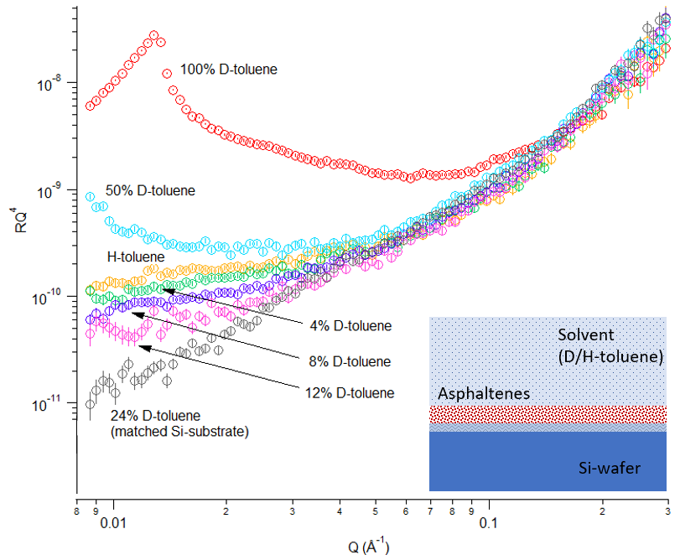

Figure 5. Reflectivity curves plotted in the form of Rq⁴ as a function of Q for pure solutions of asphaltenes (2 g/L) in mixtures of D-toluene and H-toluene. The volume fraction in D-toluene is indicated on the curves.

The neutron reflectivity data were fitted by a model that is composed of several layers, each one characterized by a certain SLD-value, thickness and a roughness. The roughness defines the region where the SLD is observed to vary gradually between two layers. A perfectly flat transition between layers would give a discontinuity in the theoretical SLD-profile. An experimentally found gradual transition (after taking into account the minor profile broadening originating from the reflectometer itself) can then be described by introducing a certain roughness, since that will modify the reflectivity of the interface. The roughness is accounted for mathematically by a function with sigmoidal shape in terms of position (z), the so-called error function (cf. eq. 5), and the numerical value is simply defined as the width (i.e. standard deviation) of this function⁶⁹.

$$erf\left(z\right)=\frac{2}{}\int_{0}^{z}{e^{-t2}dt}$$
(5)
It is important to note that the term "roughness" incorporates also a situation with interdiffusion between layers, i.e. when there is a transition region where one phase gradually diffuses into the other. Pure roughness (i.e. a sharp but geometrically non-flat transition between materials) and interdiffusion (non-sharp but flat transition region) are not distinguishable in specular reflectometry and can both be described by the error function mentioned above (cf. ref ⁷⁰). The fitting procedure consists in finding the numerical values of the thickness and roughness parameters that best explain the experimentally measured reflectivity, with the relative contribution of pure roughness and interdiffusion (if both are present) being unknown. It is also relevant to note that since the roughness is mathematically defined as the standard deviation of the error function, the total width of a transition region in the SLD diagram, as judged by simple visual inspection, will be larger than the roughness value itself. The difference will be approximately a factor of 3. Furthermore, the thickness of a layer (e.g. asphaltene) is defined as the distance between the midpoint in the transition region on each side of the layer, i.e. from the midpoint of the SiO₂-asphaltene interface to the the midpoint of the asphaltene-solvent interface. This has the consequence that for a thin layer with significant roughness on each side, the two transition regions will approach each other, so that one may not observe a region with a constant SLD-value characteristic of that material (cf. theoretical values in Table 3). The result will rather be a continuously varying SLD-profile, representing the best global fit to the reflectivity data.
The analysis of the data first started by determining the characteristics of the oxide layer on top of silicon. This was performed by fitting the reflectivity curves of the silicon wafer measured in pure D-toluene in absence of asphaltenes (see inset in Figure 6). In this situation, the reflectivity curve allows to determine the thickness and the roughness of the silicon oxide layer.
The obtained value of 13 Å for the thickness is typical of values found by other research groups for similar silicon oxide layers^{67, 71, 72}, even if the oxidative treatment can be different (sulfuric acid and hydrogen peroxide for Jouault et al. or no surface treatment for Penfold et al.). The roughness was found to be 10 Å for this system, also in the range typically found by others. Note that this corresponds to the roughness at the SiO₂ / asphaltene interface when asphaltene is present in the sample cell. These values were employed as starting inputs in the model used to fit the reflectivity curves in presence of asphaltenes and/or pluronic. There is also a small roughness for the pure silicon below the oxide layer. This was fixed to a value of 3 Å, in accordance with specifications provided by the manufacturer. It should be noted that for relatively thin layers of adsorbed material, as expected in the present case for asphaltene, a correct determination of the properties of the SiO₂ layer is critical for the evaluation of the thickness and roughness of the adsorbed layer, since the final result will be very sensitive to the SiO₂ parameters. This is due to the fact that the different contributions may be of similar size and are convoluted in the final scattering pattern.
A simultaneous fit of all the datasets that contained asphaltene (2 g/L) with different D-toluene/H-toluene ratios was made using the GenX-platform, coupling together the parameters that were unchanged while varying the SLD-values as given by the exact D/H-ratios for the solutions. The latter were determined via the known SLD-values for D-toluene (5.66 · 10⁻⁶Å⁻²) and pure H-toluene (0.94 · 10⁻⁶Å⁻²). In this manner we could strongly constrain the parameters and avoid false minima in the fitting. Note also that since we had previously determined the chemical composition of this asphaltene by elemental analysis, we could fix the SLD of asphaltene to the calculated value of 1.32 · 10⁻⁶Å⁻². This allowed us to also determine accurately the degree of solvent penetration into the asphaltene (solvation). The fitted data are shown in Figure 6, with the numerical results in Table 4. Here the values of thickness and roughness for the silicon oxide layer are also included.

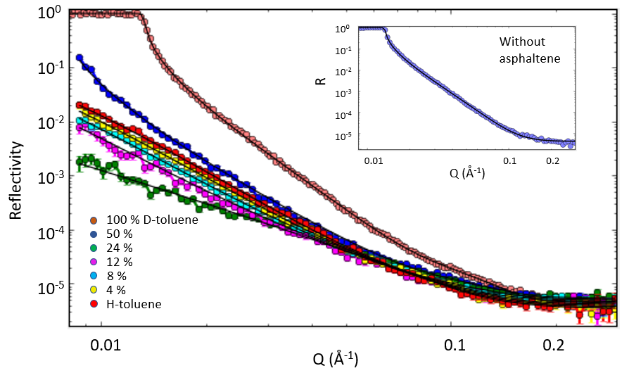

Figure 6. Reflectivity curves in the form of log R vs. log Q as a function of Q for solutions of asphaltenes (2 g/L) in mixtures of D-toluene and H-toluene. The volume fraction in D-toluene for the different samples are indicated. The continuous lines represent the model fits. Inset: Reflectivity data and model fit for the sample without asphaltene, i.e. Si-wafer and D-toluene only.

Asphaltene thickness | Asphaltene roughness | Solvation | SiO₂ thickness | SiO₂ roughness
51.4 ± 1 Å | 7.3 ± 0.5 Å | 91 ± 1 % | 13.3 ± 0.5 Å | 10.1 ± 0.5 Å

Table 4. Thickness, roughness and degree of solvent penetration for the adsorbed asphaltene (2 g/L). Values for the SiO₂ layer are also given. The figure of merit (FOM) for the simultaneous fitting was 0.034.

The thickness we find (51 Å) corresponds quite well to the diameter found earlier from bulk measurements (with SANS) on these samples, where the nanoaggregate radius was found to be ca. 30 Å, thus an approximate diameter of 60 Å. However, the value is a bit lower, and this might be expected if there is a slight compression of the nanoaggregates due to the adherence to the hydrophilic surface. Jestin et al.⁴² also found by SANS that the asphaltene layer stabilizing water-in-toluene emulsions has a thickness that is very close to twice the radius of gyration of the aggregates in solution. The thickness found in this study is lower than the values obtained by Jouault et al. and Corvis et al. ^{67, 68} (from 62 to 87 Å depending on the resin content in the asphaltene sample). The thickness is also lower than values found by SANS in model w/o emulsions (100-150 Å) ^{42, 43}. Adsorbed layer thicknesses deduced from surface-force-apparatus (SFA) measurement on bitumen asphaltene adsorbing onto silica surfaces in toluene are also higher. Indeed, Wang et al. found that the thickness (half the hard wall distance value) of the asphaltene layer increases from ≈ 60 - 75 Å to 300 Å after respectively 2 hours and 20 hours of adsorption. The difference could perhaps be linked to the variability in asphaltene structure with their origin and their preparation method (presence of resins). In general, all asphaltenes present similar behaviour/properties (nanoaggregation, flocculation, adsorption…), but the extent of these properties depends on their origin. For instance, Simon et al. have reported large variations of asphaltene nanoaggregate size in bulk depending on the crude oil origin, the preparation method (n-alkane used), and the solvent³⁸.
The roughness of the asphaltene layer towards the solvent was found to be 7.3 Å. This is relatively low, but it could still indicate a slight irregularity over the surface, or regions of dangling chains into the solvent.
It is interesting to note that the solvation is found to be very high, i.e. 91%. This value is however in line with the values reported by Justin et al.⁴² and Verruto and Kilpatrick⁴³ in their characterizations of the asphaltene layers around water droplets by SANS, where volume fractions of 10-20 % are mentioned. However, one can gain a bit more information by plotting the calculated SLD-profile versus distance. This is shown in Fig. 7 for the case of asphaltene in pure D-toluene. The main part of the asphaltene region is seen to have an SLD-value slightly above 5, corresponding to a solvation of around 90 % (s mentioned above), and thus an asphaltene concentration about 10 %. However, the SLD-value is seen to drop considerably as one approaches the SiO₂ surface, which is equivalent to a lower degree of solvation. The percentage of asphaltene can be estimated via linear interpolation between the value of pure asphaltene (SLD=1.32 ·10⁻⁶ Å⁻²) and that of pure D-toluene (SLD=5.66 · 10⁻⁶ Å⁻²), which leads to an approximate asphaltene concentration of 58 % (i.e. 42 % solvation) for the region closest to the SiO₂ surface. These results therefore indicate that there is a significant reduction in asphaltene solvation the first 10-15 Å from the surface. Note however, that this estimate is based on the somewhat simplistic picture of the asphaltene layer starting exactly at the position where the SiO₂ surface is shown to end (dark grey region in the figure). These border lines correspond with the thicknesses found for each layer (SiO₂ and asphaltene). In practice this interface is less defined and governed by the surface roughness in the model. The values noted for the asphaltene concentration are therefore rough indications, where the main point is rather the tendency of a low solvation near the surface and gradually increasing solvation away from the surface. Another point to mention is that within the experimental error of the data it would be possible to assume another mathematical function (e.g. non-smooth or non-sigmoidal) to represent the interface region with similar final χ²-values for the fitting. However, the information content of a reflectivity experiment is generally insufficient to divert from the established mathematical presentation of surface roughness that gives the transition region in the diagram. In summary this means that there is a significant uncertainty with the asphaltene concentrations given in Fig. 7. The amount is difficult to estimate, but is likely on the order of 5% or more.
One slightly surprising feature of the SLD curves is the dip in SLD in the layer we have designated SiO₂. In neutron reflectivity, one does not obtain atomic information, thus the designation SiO₂ is solely a label. However, we do expect a layer since a Si (111) surface is not stable in air, and we generally see a native oxide layer forming which is around 10-30 Å on a silicon surface. This would however have a higher SLD than bulk Si. The observed low SLD layer thus deserves some consideration. Anecdotally, such a layer is not unheard of when investigating oils (or even water) using neutron reflectivity, but its nature remains a subject of debate. One explanation is that the oleophobicity of the SiO₂ surface creates some form of “nano-bubbles”⁷³ at the surface. Another possible cause would be that any water existing in the solvent phase would naturally migrate to this surface, to form a very thin watery layer at the interface. Since hydrogen has a negative scattering length this would produce a drop in the SLD, and the required amounts of water are in the ppm range, thus very difficult to both measure and eliminate. Due to the large number of contrasts measured we can be sure of both the thickness and the SLD of this layer, and it does not affect any subsequent analysis of the asphaltenes, even if its exact composition unknown.

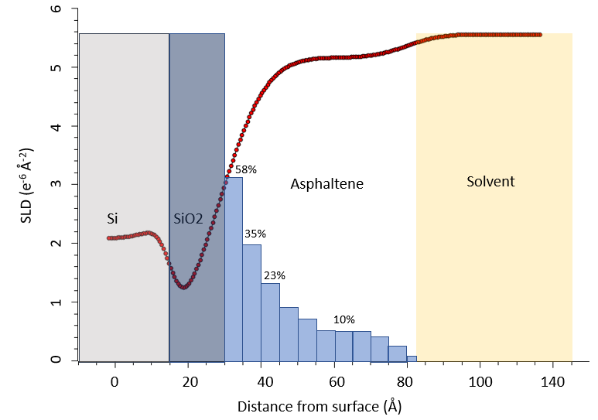

Figure 7. SLD-profile for asphaltene in D-toluene as function of distance from the Silicon surface. The region named with each component in the figure is determined by the midpoints of the transitions between the neighbouring layers, according to the definition in the fitting algorithm. An estimate of the amount of asphaltene (with respect to solvent) based on the SLD-value at different distances is shown as vertical bars.

Finally, the possibility of a "2-layer" asphaltene model was investigated. Such a situation might occur if the asphaltenes adsorbed as individual molecules with a specific preference for either the side chains or the aromatic regions being directed towards the surface. However, several variants of 2-layer models were tested on the present data, but they always converged with the second layer having zero thickness, independently of the starting values used for hydration and thicknesses of the two layers. This is a strong indication that we do not have a 2-layer structure for this system - a situation which can be expected if the asphaltene adsorbs mainly in the form of nanoaggregates already formed in solution and less in the form of individual molecules.
These neutron reflectivity measurements have allowed us to determine the concentration profile of the asphaltene layer in the normal direction from the silicon wafer. The presence and extent of lateral heterogeneities, such as patches or aggregates, cannot be determined from our measurements. Other techniques such as off-specular reflectometry ⁷⁴ or atomic force microscopy ⁷⁵ should be implemented to get such information.

Influence of Pluronic on the asphaltene layer
Figure 8 presents the reflectivity curves, given as logarithm of Rq⁴ as a function of Q for asphaltene at 2 g/L in D-toluene and asphaltene at 2 g/L + pluronic at 0.1 g/L in D-toluene. In the figure is also shown, as insets, the curve for D-toluene only and for the pluronic at 0.1 g/L in D-toluene.
The reflectivity curves in presence of asphaltenes and/or pluronic present some variations compared with the wafers measured in pure D-toluene. Specifically, there is an added contribution to the reflectivity pattern in the range above ca. Q=0.05 Å⁻¹. This highlights the presence of an adsorbed layer on top of the silicon. Even though not evident by the initial visual inspection, there are subtle differences in the reflectivity patterns between the different investigated systems, which could be used to extract thickness and roughness values by least-squares fitting and compare their variations. As mentioned previously, the methodology used to fit a reflectivity curve measured only in D-toluene without varying the D-toluene/H-toluene ratio is quite critical. It was found that different combinations of parameters, i.e. both low/high solvation vs. high/low thickness and roughness, could give reasonable fits depending on the initial guess entered in the fitting routine. For this reason, the fitting of reflectivity curves obtained in D-toluene were performed by using as reference the parameters calculated previously in the multi-contrast study. Similarly to in section 3.2.3, the characteristics of the silicon oxide layer were first determined from the reflectivity curve measured in D-toluene and in absence of asphaltenes or pluronic. These characteristics were then used as inputs to fit the reflectivity curves in presence of asphaltenes and/or pluronic. The model curves are included in the plots in Figure 8, and the characteristics of the adsorbed layer for the different systems are presented in Table 5. It should be noted, however, that the error bars are relatively large for these values due to fact that this is not a contrast variation study.

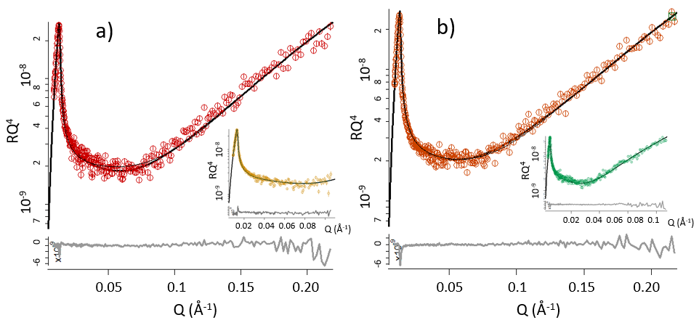
Figure 8. Reflectivity curves Rq⁴ as a function of Q and model curves (continuous lines) for a) asphaltenes at 2 g/L in d-toluene and b) asphaltenes at 2 g/L + pluronic at 0.1 g/L in d-toluene. The inset in a) shows the pattern for d-toluene only and in b) the pluronic at 0.1 g/L in d-toluene. The differences between the data and the fitted curves are presented as grey lines at the bottom of the figures and in the insets.

The pure asphaltene layer was found to have a thickness of ca. 47 Å with a relatively small roughness (4 Å). These values are relatively similar to the ones found in the contrast matching experiments. We note that the asphaltene is found to have a high degree of solvation, above 90 %. Due to the signal-noise level of the data, this value cannot be determined very accurately. However, the value is in line with the contrast variation experiment presented in the previous section.
The pluronic layer was found to have a smaller thickness of ca. 28 Å with a roughness of 6 Å. A size of 28 Å is equivalent to 18 C-C single bonds. Therefore, considering the molecular weight of the pluronic (2600 g/mol ⁴⁵), equivalent to 186 C-C bonds, that means that the pluronic chains are not protruding very far into the solvent and adopt a relatively flat conformation on silicon oxide. Shar et al. obtained similar conclusions by measuring the hydrodynamic thickness of pluronic adsorbed on silica particles in aqueous solution⁶⁶.We note that the relative size of the pluronic layer with respect to that of the asphaltene (28Å/47Å) is quite close to the ratio of adsorbed amount of these compounds as found from the QCM data, indicating that the reflectometry and QCM experiments are comparable.
The layer formed with a mixed solution of asphaltenes and pluronic presents a slightly shorter layer thickness (36 Å) than the pure asphaltene layer. This reduction indicates that the pluronic is partially incorporated into the asphaltene layer. The percentage reduction of the thickness (23 %) is in quite good agreement with the reduction of the adsorbed amount when pluronic is present, as found from QCM.

System | Thickness (Å) | Roughness (Å) | Solvation (volume percent)
D-toluene (SiO₂ surface layer) | 13.9 | 7.9 | -
Asphaltenes 2 g/L | 47 | 4 | 94
Pluronic 0.1 g/L | 28 | 6 | 35
Asphaltenes 2 g/L + Pluronic 0.1 g/L * | 36 | 4 | 24

Table 5. Thickness, roughness and solvation degree for the various investigated systems obtained by fitting the reflectivity data presented in figure 8. The errors in the fitted thickness and roughness are approx. 2.0 Å Solvent: d-toluene. *: For this sample the errors are larger because also the SLD-value was fitted (since the composition ratio between asphaltenes and pluronics inside the layer is not known).

It should be noted that for the mixed system of asphaltene and pluronic, the SLD was fitted to an approximate value of 0.9x10⁻⁶ Å⁻². This is lower than that of asphaltene (1.32x10⁻⁶ Å⁻²), and higher than that of pure pluronic (0.5 ·10⁻⁶ Å⁻²). This shows that the pluronic is at least partially incorporated into the asphaltene layer. The roughness of 4 Å found for this mixed layer (cf. Table 5) is a coarse value, i.e. with quite large uncertainty, due to the limited information content of the data when the exact SLD of the layer is not known a priori.

CONCLUSIONS
The use of two different neutron scattering techniques, SANS and neutron reflectometry, made it possible to study the behaviour of the same source of asphaltenes both in solution (bulk) and when adsorbed onto a solid surface. The bulk measurements demonstrated that these asphaltenes tend to form nanoaggregates when dissolved in D-toluene, with an overall diameter of around 6 nm, and that addition of heptane increases the size of the aggregates for heptane fractions above 25 %. Addition of the model demulsifier DBSA showed an initial increase of the nanoaggregate size due to adherence of DBSA, with a subsequent size decrease upon further addition of DBSA, consistent with a peptization mechanism.
The reflectometry studies were performed using a contrast variation technique, whereby a series of D-toluene/H-toluene ratios were employed to change the scattering contrast between the solvent, the solid surface, and the adsorbed layer. This turned out to be crucial to extract reliable values for the adsorbed asphaltene, particularly due to the high degree of solvent penetration for this asphaltene. An asphaltene thickness of 51 Å and roughness of 7 Å, as well as an average solvation of 91 % was found in this study. This asphaltene thickness corroborates a situation where nanoaggregates from the solution adsorb onto the silicon surface - possibly due to some unshielded polar entities interacting with the hydrophilic surface, as shown by dissipative particle dynamics (DPD) simulation results⁷⁶ - and where the aggregates become moderately compressed in the process. The high degree of solvation is in accord with indirect results obtained by Jestin et al. on a different asphaltene source. On the other hand, one cannot exclude that this value, which is an average over the surface, might be due partly to some areas not being fully covered by asphaltene (thus containing mainly solvent). Such a situation will also affect the average surface roughness, that was here measured to 7 Å. It should furthermore be noted that the SLD-curve extracted from the fitting indicate a lower degree of solvation of the asphaltene close to the surface.
Finally, the adsorption onto a hydrophilic surface of the model demulsifier pluronic in combination with asphaltene was studied. The pluronic alone shows a significantly weaker surface adsorption than asphaltene. Furthermore, when pluronic is added (0.1 g/L), the thickness of the adsorbed asphaltene layer is reduced with approximately 25 %, showing the demulsifying effect of pluronic. These results were also in good accordance with data obtained independently from QCM measurements.

AUTHOR INFORMATION
Corresponding Author
* Tel.: (+47) 73 59 16 57. Fax: (+47) 73 59 40 80. E-mail: sebastien.simon@chemeng.ntnu.no

ACKNOWLEDGEMENT

The authors thank the JIP Electrocoalesence consortium “New Strategy for Separation of Complex Water-in-Crude Oil Emulsions: From Bench to Large Scale Separation”, consisting of Ugelstad Laboratory (NTNU, Norway), University of Alberta (Canada), Swiss Federal Institute of Technology in Zurich (Switzerland), and Institutt for energiteknikk (IFE, Norway) and funded by Norwegian Research Council (Petromaks II Grant 255174) and the following industrial sponsors: Anvendt Teknologi AS, NalcoChampion, Nouryon, Equinor, and Sulzer. This work is based on experiments performed at the Swiss spallation neutron source SINQ, Paul Scherrer Institute, Villigen PSI, Switzerland, and at the ISIS Neutron and Muon Source, UK. Experiments at SINQ were supported by beamtime allocation 20170059. Experiments at the ISIS Neutron and Muon Source were supported by a beamtime allocation RB1820191 ​ from the Science and Technology Facilities Council (DOI: 10.5286/ISIS.E.98000988). The authors thank Einar Eng Johnsen (Equinor) for his comments on the manuscript.

REFERENCES

1. Fakhru’l-Razi, A.; Pendashteh, A.; Abdullah, L. C.; Biak, D. R. A.; Madaeni, S. S.; Abidin, Z. Z., Review of technologies for oil and gas produced water treatment. Journal of Hazardous Materials 2009, 170, (2–3), 530-551.
2. Eow, J. S.; Ghadiri, M., Electrostatic enhancement of coalescence of water droplets in oil: a review of the technology. Chemical Engineering Journal 2002, 85, (2–3), 357-368.
3. Eow, J. S.; Ghadiri, M.; Sharif, A. O.; Williams, T. J., Electrostatic enhancement of coalescence of water droplets in oil: a review of the current understanding. Chemical Engineering Journal 2001, 84, (3), 173-192.
4. Less, S.; Hannisdal, A.; Bjørklund, E.; Sjöblom, J., Electrostatic destabilization of water-in-crude oil emulsions: Application to a real case and evaluation of the Aibel VIEC technology. Fuel 2008, 87, (12), 2572-2581.
5. Al-Sabagh, A. M.; Kandile, N. G.; Noor El-Din, M. R., Functions of Demulsifiers in the Petroleum Industry. Separation Science and Technology 2011, 46, (7), 1144-1163.
6. Sjöblom, J.; Aske, N.; Harald Auflem, I.; Brandal, O.; Erik Havre, T.; Saether, O.; Westvik, A.; Eng Johnsen, E.; Kallevik, H., Our Current Understanding of Water-in-Crude Oil Emulsions.: Recent Characterization Techniques and High Pressure Performance. Adv. Colloid Interface Sci. 2003, 100-102, 399-473.
7. Grutters, M.; van Dijk, M.; Dubey, S.; Adamski, R.; Gelin, F.; Cornelisse, P., Asphaltene Induced W/O Emusilon: False or True? J. Dispersion Sci. Technol. 2007, 28, (3), 357-360.
8. Sjöblom, J.; Simon, S.; Xu, Z., Model molecules mimicking asphaltenes. Advances in Colloid and Interface Science 2015, 218, (0), 1-16.
9. Hanneseth, A.-M. D.; Selsbak, C.; Sjöblom, J., Behavior and Stability of Naphthenic Acid/Naphthenate Stabilized Emulsions. Mixed C80-Tetraacid and Stearic Acid Stabilization. Journal of Dispersion Science and Technology 2010, 31, (6), 770-779.
10. Arla, D.; Sinquin, A.; Palermo, T.; Hurtevent, C.; Graciaa, A.; Dicharry, C., Influence of pH and Water Content on the Type and Stability of Acidic Crude Oil Emulsions. Energy Fuels 2007, 21, (3), 1337-1342.
11. Ese, M. H.; Kilpatrick, P. K., Stabilization of Water-in-Oil Emulsions by Naphthenic Acids and Their Salts: Model Compounds, Role of pH, and Soap:Acid Ratio. J. Dispersion Sci. Technol. 2004, 25, (3), 253-261.
12. Sullivan, A. P.; Kilpatrick, P. K., The Effects of Inorganic Solid Particles on Water and Crude Oil Emulsion Stability. Ind. Eng. Chem. Res. 2002, 41, (14), 3389-3404.
13. Hannisdal, A.; Ese, M.-H.; Hemmingsen, P. V.; Sjoblom, J., Particle-stabilized emulsions: Effect of heavy crude oil components pre-adsorbed onto stabilizing solids. Colloids Surf., A 2006, 276, (1-3), 45-58.
14. Kralova, I.; Sjöblom, J.; Øye, G.; Simon, S.; Grimes, B. A.; Paso, K., Heavy Crude Oils/Particle Stabilized Emulsions. Advances in Colloid and Interface Science 2011, 169, (2), 106-127.
15. Speight, J. G., Petroleum Asphaltenes - Part 1: Asphaltenes, Resins and the Structure of Petroleum Oil & Gas Science and Technology 2004, 59, (5), 467-477
16. Subramanian, S.; Simon, S.; Gao, B.; Sjöblom, J., Asphaltene fractionation based on adsorption onto calcium carbonate: Part 1. Characterization of sub-fractions and QCM-D measurements. Colloids and Surfaces A: Physicochemical and Engineering Aspects 2016, 495, 136-148.
17. Subramanian, S.; Sørland, G. H.; Simon, S.; Xu, Z.; Sjöblom, J., Asphaltene fractionation based on adsorption onto calcium carbonate: Part 2. Self-association and aggregation properties. Colloids and Surfaces A: Physicochemical and Engineering Aspects 2017, 514, 79-90.
18. Groenzin, H.; Mullins, O. C., Asphaltene Molecular Size and Structure. J. Phys. Chem. A 1999, 103, (50), 11237-11245.
19. Groenzin, H.; Mullins, O. C., Molecular Size and Structure of Asphaltenes from Various Sources. Energy & Fuels 2000, 14, (3), 677-684.
20. Groenzin, H.; Mullins, O. C., Molecular Size and Structure of Asphaltenes. Petroleum Science and Technology 2001, 19, (1-2), 219-230.
21. Groenzin, H.; Mullins, O. C.; Eser, S.; Mathews, J.; Yang, M. G.; Jones, D., Molecular Size of Asphaltene Solubility Fractions. Energy Fuels 2003, 17, (2), 498-503.
22. Hortal, A. R.; Martínez-Haya, B.; Lobato, M. D.; Pedrosa, J. M.; Lago, S., On the determination of molecular weight distributions of asphaltenes and their aggregates in laser desorption ionization experiments. Journal of Mass Spectrometry 2006, 41, (7), 960-968.
23. Pomerantz, A. E.; Hammond, M. R.; Morrow, A. L.; Mullins, O. C.; Zare, R. N., Two-Step Laser Mass Spectrometry of Asphaltenes. Journal of the American Chemical Society 2008, 130, (23), 7216-7217.
24. Pomerantz, A. E.; Hammond, M. R.; Morrow, A. L.; Mullins, O. C.; Zare, R. N., Asphaltene Molecular-Mass Distribution Determined by Two-Step Laser Mass Spectrometry†. Energy & Fuels 2008, 23, (3), 1162-1168.
25. Mitra-Kirtley, S.; Mullins, O. C.; Van Elp, J.; George, S. J.; Chen, J.; Cramer, S. P., Determination of the nitrogen chemical structures in petroleum asphaltenes using XANES spectroscopy. Journal of the American Chemical Society 1993, 115, (1), 252-258.
26. Simon, S.; Nenningstand, A. L.; Herschbach, E.; Sjoblom, J., Extraction of Basic Components from Petroleum Crude Oil. Energy & Fuels 2010, 24, 1043-1050.
27. Speight, J. G., The Chemistry and Technology of Petroleum, 4th Edition. CRC Press: 2007.
28. Murgich, J., Molecular Simulation and the Aggregation of the Heavy Fractions in Crude Oils. Molecular Simulation 2003, 29, (6-7), 451-461.
29. Schuler, B.; Meyer, G.; Peña, D.; Mullins, O. C.; Gross, L., Unraveling the Molecular Structures of Asphaltenes by Atomic Force Microscopy. Journal of the American Chemical Society 2015, 137, (31), 9870-9876.
30. Mullins, O. C., The Modified Yen Model. Energy & Fuels 2010, 24, (4), 2179-2207.
31. Fenistein, D.; Barre, L.; Frot, D., From Aggregation to Flocculation of Asphaltenes, a Structural Description by Radiation Scattering Techniques. Oil & Gas Science and Technology 2000, 55, (1), 123-128
32. Anisimov, M. A.; Yudin, I. K.; Nikitin, V.; Nikolaenko, G.; Chernoutsan, A.; Toulhoat, H.; Frot, D.; Briolant, Y., Asphaltene Aggregation in Hydrocarbon Solutions Studied by Photon Correlation Spectroscopy. The Journal of Physical Chemistry 1995, 99, (23), 9576-9580.
33. Wang, X.; Zhang, R.; Liu, L.; Qiao, P.; Simon, S.; Sjöblom, J.; Xu, Z.; Jiang, B., Interactions of Polyaromatic Compounds. Part 2. Flocculation Probed by Dynamic Light Scattering and Molecular Dynamics Simulation. Energy & Fuels 2017, 31, (9), 9201-9212.
34. Dickie, J. P.; Yen, T. F., Macrostructures of the asphaltic fractions by various instrumental methods. Analytical chemistry 1967, 39, (14), 1847-1852.
35. Mullins, O. C.; Sabbah, H.; Eyssautier, J.; Pomerantz, A. E.; Barré, L.; Andrews, A. B.; Ruiz-Morales, Y.; Mostowfi, F.; McFarlane, R.; Goual, L.; Lepkowicz, R.; Cooper, T.; Orbulescu, J.; Leblanc, R. M.; Edwards, J.; Zare, R. N., Advances in Asphaltene Science and the Yen–Mullins Model. Energy & Fuels 2012, 26, (7), 3986-4003.
36. Pfeiffer, J. P.; Saal, R. N. J., Asphaltic bitumen as colloid system. Journal of Physical Chemistry 1940, 44, 139-149.
37. Fenistein, D.; Barre, L., Experimental measurement of the mass distribution of petroleum asphaltene aggregates using ultracentrifugation and small-angle X-ray scattering. Fuel 2001, 80, (2), 283-287.
38. Simon, S.; Jestin, J.; Palermo, T.; Barre, L., Relation between Solution and Interfacial Properties of Asphaltene Aggregates. Energy & Fuels 2009, 23, (1), 306-313.
39. Subramanian, S.; Simon, S.; Sjöblom, J., Interaction between asphaltenes and fatty-alkylamine inhibitor in bulk solution. Journal of Dispersion Science and Technology 2018, 39, (2), 163-173.
40. Teklebrhan, R. B.; Ge, L.; Bhattacharjee, S.; Xu, Z.; Sjöblom, J., Probing Structure–Nanoaggregation Relations of Polyaromatic Surfactants: A Molecular Dynamics Simulation and Dynamic Light Scattering Study. The Journal of Physical Chemistry B 2012, 116, (20), 5907-5918.
41. Jian, C.; Tang, T.; Bhattacharjee, S., Probing the Effect of Side-Chain Length on the Aggregation of a Model Asphaltene Using Molecular Dynamics Simulations. Energy & Fuels 2013, 27, (4), 2057-2067.
42. Jestin, J.; Simon, S.; Zupancic, L.; Barre, L., A Small Angle Neutron Scattering Study of the Adsorbed Asphaltene Layer in Water-in-Hydrocarbon Emulsions: Structural Description Related to Stability. Langmuir 2007, 23, (21), 10471-10478.
43. Verruto, V. J.; Kilpatrick, P. K., Water-in-Model Oil Emulsions Studied by Small-Angle Neutron Scattering: Interfacial Film Thickness and Composition. Langmuir 2008, 24, (22), 12807-12822.
44. Kelland, M. A., Production Chemicals for the Oil and Gas Industry, Second Edition. CRC Press 2014; p 454.
45. Pluronic PE types, Technical Information TI/ES 1026 e, BASF; 1996.
46. Adachi, S.; Utani, K., Chemical Treatment Effects of Si Surfaces in NH4OH:H2O2:H2O Solutions Studied by Spectroscopic Ellipsometry. Japanese Journal of Applied Physics 1993, 32, (Part 2, No. 9A), L1189-L1191.
47. Barre, L.; Simon, S.; Palermo, T., Solution Properties of Asphaltenes. Langmuir 2008, 24, 3709-3717.
48. Fenistein, D.; Barre, L.; Broseta, D.; Espinat, D.; Livet, A.; Roux, J. N.; Scarsella, M., Viscosimetric and Neutron Scattering Study of Asphaltene Aggregates in Mixed Toluene/Heptane Solvents. Langmuir 1998, 14, (5), 1013-1020.
49. Fossen, M.; Kallevik, H.; Knudsen, K. D.; Sjöblom, J., Asphaltenes Precipitated by a Two-Step Precipitation Procedure. 1. Interfacial Tension and Solvent Properties. Energy & Fuels 2007, 21, (2), 1030-1037.
50. Clemens, D.; Gross, P.; Keller, P.; Schlumpf, N.; Könnecke, M., AMOR – the versatile reflectometer at SINQ. Physica B: Condensed Matter 2000, 276-278, 140-141.
51. Nelson, A. Analysis of multiple contrast X-ray and Neutron Reflectometry data - Motofit mode, Revision 409; 2009.
52. IGOR Pro, Version 6.37; Wavemetrics Inc: 2014.
53. Bjorck, M. GenX, 2008.
54. Sauerbrey, G., Verwendung von Schwingquarzen zur Wägung dünner Schichten und zur Mikrowägung. Zeitschrift für Physik 1959, 155, (2), 206-222.
55. Eyssautier, J.; Frot, D.; Barré, L., Structure and Dynamic Properties of Colloidal Asphaltene Aggregates. Langmuir 2012, 28, (33), 11997-12004.
56. Espinat, D.; Fenistein, D.; Barre, L.; Frot, D.; Briolant, Y., Effects of Temperature and Pressure on Asphaltenes Agglomeration in Toluene. A Light, X-ray, and Neutron Scattering Investigation. Energy Fuels 2004, 18, (5), 1243-1249.
57. Spiecker, P. M.; Gawrys, K. L.; Kilpatrick, P. K., Aggregation and solubility behavior of asphaltenes and their subfractions. Journal of Colloid and Interface Science 2003, 267, (1), 178-193.
58. Spiecker, P. M.; Gawrys, K. L.; Trail, C. B.; Kilpatrick, P. K., Effects of petroleum resins on asphaltene aggregation and water-in-oil emulsion formation. Colloids and Surfaces A: Physicochemical and Engineering Aspects 2003, 220, (1-3), 9-27.
59. Roux, J. N.; Broseta, D.; Deme, B., SANS Study of Asphaltene Aggregation: Concentration and Solvent Quality Effects. Langmuir 2001, 17, (16), 5085-5092.
60. Pedersen, J. S., Analysis of small-angle scattering data from colloids and polymer solutions: modeling and least-squares fitting. Advances in Colloid and Interface Science 1997, 70, 171-210.
61. Gawrys, K. L.; Kilpatrick, P. K., Asphaltenic aggregates are polydisperse oblate cylinders. Journal of Colloid and Interface Science 2005, 288, (2), 325-334.
62. Gawrys, K. L.; Blankenship, G. A.; Kilpatrick, P. K., Solvent Entrainment in and Flocculation of Asphaltenic Aggregates Probed by Small-Angle Neutron Scattering. Langmuir 2006, 22, (10), 4487-4497.
63. Chang, C.-L.; Fogler, H. S., Stabilization of Asphaltenes in Aliphatic Solvents Using Alkylbenzene-Derived Amphiphiles. 1. Effect of the Chemical Structure of Amphiphiles on Asphaltene Stabilization. Langmuir 1994, 10, (6), 1749-1757.
64. Raj, G.; Larkin, E.; Lesimple, A.; Commins, P.; Whelan, J.; Naumov, P., In Situ Monitoring of the Inhibition of Asphaltene Adsorption by a Surfactant on Carbon Steel Surface. Energy & Fuels 2019, 33, (3), 2030-2036.
65. Pradilla, D.; Subramanian, S.; Simon, S.; Sjöblom, J.; Beurroies, I.; Denoyel, R., Microcalorimetry Study of the Adsorption of Asphaltenes and Asphaltene Model Compounds at the Liquid–Solid Surface. Langmuir 2016, 32, (29), 7294-7305.
66. Shar, J. A.; Obey, T. M.; Cosgrove, T., Adsorption studies of polyethers: Part II: adsorption onto hydrophilic surfaces. Colloids and Surfaces A: Physicochemical and Engineering Aspects 1999, 150, (1), 15-23.
67. Jouault, N.; Corvis, Y.; Cousin, F.; Jestin, J.; Barré, L., Asphaltene Adsorption Mechanisms on the Local Scale Probed by Neutron Reflectivity: Transition from Monolayer to Multilayer Growth above the Flocculation Threshold. Langmuir 2009, 25, (7), 3991-3998.
68. Corvis, Y.; Barré, L.; Jestin, J.; Gummel, J.; Cousin, F., Asphaltene adsorption mechanism under shear flow probed by in situ neutron reflectivity measurements. The European Physical Journal Special Topics 2012, 213, (1), 295-302.
69. Névot, L.; Croce, P., Caractérisation des surfaces par réflexion rasante de rayons X. Application à l'étude du polissage de quelques verres silicates. Rev. Phys. Appl. (Paris) 1980, 15, (3), 761-779.
70. Cousin, F.; Menelle, A., Neutron reflectivity. EPJ Web of Conferences 2015, 104, 01005.
71. Fragneto, G.; Lu, J. R.; McDermott, D. C.; Thomas, R. K.; Rennie, A. R.; Gallagher, P. D.; Satija, S. K., Structure of Monolayers of Tetraethylene Glycol Monododecyl Ether Adsorbed on Self-Assembled Monolayers on Silicon: A Neutron Reflectivity Study. Langmuir 1996, 12, (2), 477-486.
72. Penfold, J.; Staples, E. J.; Tucker, I.; Thompson, L. J.; Thomas, R. K., The structure and composition of mixed cationic and non-ionic surfactant layers adsorbed at the hydrophilic silicon surface. Physica B: Condensed Matter 1998, 248, (1), 223-228.
73. Gutfreund, P.; Maccarini, M.; Dennison, A. J. C.; Wolff, M., The Search for Nanobubbles by Using Specular and Off-Specular Neutron Reflectometry. Langmuir 2016, 32, (35), 9091-9096.
74. Pynn, R.; Baker, S. M.; Smith, G.; Fitzsimmons, M., Off-specular scattering in neutron reflectometry. Journal of Neutron Research 1999, 7, (3-4), 139-158.
75. Manne, S.; Schäffer, T. E.; Huo, Q.; Hansma, P. K.; Morse, D. E.; Stucky, G. D.; Aksay, I. A., Gemini Surfactants at Solid−Liquid Interfaces: Control of Interfacial Aggregate Geometry. Langmuir 1997, 13, (24), 6382-6387.
76. Skartlien, R.; Simon, S.; Sjöblom, J., DPD Molecular Simulations of Asphaltene Adsorption on Hydrophilic Substrates: Effects of Polar Groups and Solubility. Journal of Dispersion Science and Technology 2016, 37, (6), 866-883.

