Interactions Between Asphaltenes and a Model Demulsifier in Bulk and at an Interface Studied by Small-angle Neutron Scattering (SANS) and Neutron Reflectometry

Kenneth D. Knudsen,†,∥ Sébastien Simon,*,⊥ Thomas Geue#, Joshaniel F. K. Cooper‡, Johan Sjöblom⊥

†Institute for Energy Technology (IFE), N-2007 Kjeller, Norway
∥Department of Physics, the Norwegian University of Science and Technology (NTNU), N-7491 Trondheim, Norway

⊥Ugelstad Laboratory, Department of Chemical Engineering, the Norwegian University of Science and Technology (NTNU), N-7491 Trondheim, Norway

# Laboratory for Neutron Scattering and Imaging (LNS), Paul Scherrer Institute, CH-5232 Villigen PSI, Switzerland

‡ ISIS Neutron and Muon Source, Science and Technology Facilities Council, Rutherford Appleton Laboratory, Harwell Science and Innovation Campus, Oxon OX11 0QX, United Kingdom

KEYWORDS: Asphaltenes, Demulsification, SANS, Neutron Reflectometry

ABSTRACT: This article describes neutron reflectometry to probe the structure of the asphaltene layer adsorbed onto a hydrophilic silicon surface and the interactions between asphaltenes and a model demulsifier (pluronic).
To start with, asphaltene nanoaggregation is studied in bulk by Small-Angle Neutron Scattering (SANS). In pure toluene, asphaltenes form nanoaggregates with sizes that are found to moderately increase when heptane is added. Then the structure of the asphaltene layer onto a silicon surface is determined by neutron reflectometry. It is first shown that conclusive results on the structure of the adsorbed asphaltene layer can only be determined by varying the scattering length density of the solvent, i.e. by measuring reflectivity curves in various mixtures of D- and H-toluene and by simultaneously fitting all the datasets. The asphaltene layer can be successfully modelled using a single layer; a 2-layer models always converges with the second layer having zero thickness. This layer has a thickness of 51 Å, with a low solvation close to the silicon surface (estimated ≈29 %). The solvation increases with distance from the silicon oxide layer, reaching finally a value of 91 %. Small-Angle Neutron Scattering data indicate that the thickness is close to twice the radius of gyration of asphaltene nanoaggregates is solution. This result indicates that the extent of the asphaltene layer is linked to its self-associative properties in bulk. Finally, by using the results obtained by contrast matching to constrain the fitting, the influence of a model demulsifier (pluronic PE 8100) on the asphaltene layer is investigated. In presence of pluronic, the layer does not protrude as far into the bulk (thickness is reduced) and becomes rougher due to the partial incorporation of pluronic.

INTRODUCTION
The production of crude oil is associated with the co-production of important amounts of water. Indeed, in 2009 on a world-basis, 250 million barrels of water was co-produced (water cut ca. 70 %) along with the 80 million barrels ¹. This water is generally present as water-in-oil (w/o) emulsions. These emulsions need to be processed to obtain oil containing less than 0.5 % of water to be exported, and water with a concentration of oil in the water phase lower than 30 ppm to be discharged. The oil-water separation process is based on gravity difference between oil and water. It takes place in multi-stage gravity separators, which allows the sedimentation and the coalescence of water droplets. Various strategies can be implemented to speed up the separation: heating to reduce the viscosity of the oil phase and improving coalescence by either implementing electric fields (electrocoalescence²⁻⁴) and/or adding cocktails of chemicals named demulsifiers⁵.
Crude oil emulsions are stabilized by various crude oil components⁶, namely asphaltenes^{7, 8}, naphthenic acids⁹⁻¹¹, and resins, and also by inorganic particles¹²⁻¹⁴ (Pickering emulsions). In addition, there are interactions between these components. Asphaltenes and resins can adsorb onto solid particles modifying their wettability and their emulsion-stabilizing properties^{12, 13}. In principle, particles and other crude oil components could co-adsorb at the liquid/liquid interface.
Asphaltenes are the most polar compounds present in crude oil. They are defined as the fraction of oil insoluble in n-alkane such as n-pentane, n-hexane, and n-heptane, and soluble in aromatic solvents such as toluene or xylene^{6, 15}. Asphaltenes are mixtures of molecules differing in molecular weight and chemical structure^{16, 17}. Fluorescence depolarization techniques¹⁸⁻²¹, subsequently confirmed by mass spectrometry²²⁻²⁴, have shown that typical mean molecular weights of asphaltenes are ca. 750 g·mol⁻¹ with a factor of two in the width of the molecular weight distribution. Asphaltenes include significant amounts of heteroatoms (nitrogen, oxygen, and sulfur) and metals, the most abundant being iron, nickel, and vanadium. The presence of heteroatoms make the asphaltenes relatively polar with the presence of functional groups like pyridine or pyrrole in the case of nitrogen^{25, 26}, and carboxylic acid, phenol, or ketone for oxygen²⁷. It has also been shown that asphaltenes are polyaromatic. Based on all the structural characterization results, different models have been suggested to represent an “average” asphaltene molecule: the archipelago and the continental models²⁸. The latest published results, for instance the direct visualization of asphaltene molecules by atomic force microscopy (AFM) and molecular orbital imaging using scanning tunneling microscopy (STM) ²⁹, seem to point towards the second³⁰. However, this predominance could be sample-dependent, as recently shown by Chacón-Patiño et al.³¹ using mass spectrometry techniques. In the continental model, asphaltenes are composed of a single polyaromatic ring with aliphatic and/or naphthenic substituents while there are several polyaromatic rings linked together in the archipelago model.
Asphaltenes are prompt to self-associate in bulk both in model solvent and in crude oil. Two scales have two be considered³². First, in good solvent conditions like toluene or xylene, asphaltenes form nanometre-sized aggregates, subsequently referred to as nanoaggregates, that are stable in time. If the solvent conditions get worse (by addition of a precipitant like an alkane for instance) and the precipitation onset is reached, asphaltenes start to flocculate or undergo a phase transition to form micrometre-sized flocs^{33, 34}.
Small-Angle X-Ray Scattering (SAXS) and Small-Angle Neutron Scattering (SANS) are often used to study the nanoaggregate properties of asphaltenes in bulk, since light scattering methods are not ideal due to the opacity of the solutions. Size and molecular weight of nanoaggregates have been determined by analysing scattering curves at low scattering vector Q using equations that do not assume any particular shape of the asphaltene nanoaggregates (Guinier or Zimm equation) or by fitting the entire curve assuming a shape of spheres, or oblate or prolate cylinders. In spite of the diversity of analysis methods, most SAXS and SANS studies converge on nanoaggregate sizes between ca. 2 and 10 nm depending on the origin of the asphaltenes, the nature of the solvent, and the temperature³⁵⁻⁴⁴.
Different models have been proposed to describe the asphaltene nanoaggregation: The Yen model⁴⁵ and its updated version: The Yen-Mullins model^{30, 46}, the Peptization model by Pfeiffer et al.⁴⁷, and the application of fractal concepts^{38, 40}. In the Yen-Mullins model^{30, 46}, ca. six asphaltene molecules self-associate to form nanoaggregates by π–π stacking of their polyaromatic parts. At higher concentrations, nanoaggregates form clusters again with small aggregation numbers. The study by Eyssautier et al.⁴⁸ combining Small-Angle Neutron Scattering (SANS) and Small-Angle X-ray Scattering (SAXS) describes asphaltene nanoaggregates as formed by the fractal aggregation of small core-shell disks. This study is consistent with the Yen-Mullins model. The aggregation extent seem to be a trade-off between attractive interactions (π–π stacking, Hydrogen bonds⁴⁹…) and repulsions due to steric hindrance by aliphatic chains^{50, 51}.
The structure of the asphaltene layer on water droplets has been studied by Small-Angle Neutron Scattering using model systems by Jestin et al.⁵² and Verruto and Kilpatrick⁵³. These authors have managed to determine the values of the following parameters: Adsorbed amount at the interface ≈ 2 mg/m², volume fraction of asphaltenes in the adsorbed layer ≈ 10 – 30 %, and thickness of the adsorbed layer ≈10-15 nanometres.
Demulsifiers are molecules designed to increase the oil-water separation rate⁵. They entail a large variety of chemical structures ranked in 10 different chemical classes by Kelland⁵⁴. However, this author notes that most of the demulsifiers are non-ionic polymers with molecular weight typically in the 2000-5000 g/mol range, even if some demulsifiers can be much bigger. Moreover, generally demulsifiers contain polyalkoxylate chains like ethylene oxide (EO) and propylene oxide (PPO). Demulsifiers are generally injected at a dosage of a few tens of ppm in production facilities. The choice of the demulsifier for a specific oil field is still based on trial and error involving multiple bottle tests.
In order to obtain better knowledge about the mechanism of demulsification, in the present study the structure of the asphaltene layer was determined at the silica/toluene interface by neutron reflectometry (NR). This setup was chosen in order to mimic the water-oil interface present in crude oil emulsions. Then the interactions between asphaltenes and a model demulsifier (pluronic PE 8100) were studied with the same technique. The size of asphaltene aggregates dissolved in model organic solvents were also examined by Small-Angle Neutron Scattering (SANS) to determine the relationships between surface and bulk properties.

EXPERIMENTAL SECTION

Chemicals
Asphaltenes were obtained by precipitation from a Norwegian heavy crude oil. Briefly, n-hexane was added to the crude oil at a ratio of 40 mL hexane/g crude oil and stirred overnight. Then the asphaltene was recovered after filtration using a 0.45 µm HVLP (Millipore) membrane filter and dried in a nitrogen environment. The elemental composition of asphaltenes obtained from the same crude oil and the same procedure is presented in Subramanian et al.¹⁷ The flocculation onset of the asphaltenes was determined by optical microscopy to be comprised between 70/30 and 60/40 % v/v H-heptane/H-toluene at a concentration of 2 g/L for 1 hour and 1 day-aged solutions. After 1 week, a few flocs are difficultly visible in 60/40 % v/v H-heptane/H-toluene indicating that the flocculation onset must be close to this value, while no floc is visible in 50/50 % v/v H-heptane/H-toluene.
Pluronic PE 8100 was obtained from BASF. The pluronic is a triblock copolymer PEO_{x}-PPO_{y}-PEO_{z} with a molecular weight of ca. 2600 g/mol and 10 % PEO groups⁵⁵.
Silicon wafers were obtained from two different providers: The experiments at Paul Scherrer Institute were performed using silicon wafers from SPM AG (Liechtenstein) of dimensions 100 x 50 x 10mm (DSP < 10 Å). The silicon wafer used at the Rutherford Appleton Laboratory was from Crystran Limited (UK). It is a silicon block (111) of N-type of dimensions 80 x 50 x 15 mm (Surface roughness, Ra < 4 Å).
Silica QSX 303 crystals from Biolin Scientific were used for the QCM experiments.
Deuterated toluene (≥ 99.6 atom % D) was from Sigma-Aldrich, while deuterated heptane was from Chiron (Norway).

Preparation of Solutions and Surfaces
Asphaltene solutions were prepared by dissolving solid asphaltenes in deuterated and hydrogenated toluene. The solutions were then sonicated for half an hour and shaken overnight. Finally, the asphaltene solutions were mixed with heptane, toluene, and pluronic solutions in toluene to the desired mixture compositions.
The silicon wafers and QCM crystals were chemically handled before use to obtain a well-defined oxide layer at their surface with the following treatment⁵⁶. First, the wafers were thoroughly rinsed with Milli-Q water (Millipore) and treated with a solution composed of ammonia (30 % solution), hydrogen peroxide (30% solution) and Milli-Q water (volume ratio 1:1:5) at 75°C for 15 minutes. The crystals were then thoroughly rinsed with Milli-Q water and dried. For wafers that had already been used previously (except QCM crystals), they were first washed with H-toluene and acetone and dried out before being treated with NH₃/H₂O₂/H₂O.

Small-Angle Neutron Scattering (SANS)
SANS measurements were used to determine the size of asphaltene aggregates. It is a technique that has also been applied before to characterize asphaltene samples (size, molecular weight, shape^{36, 39, 44}).
The SANS measurements were performed at the IFE facilities in Kjeller, Norway using the JEEP-II reactor. The samples were introduced in 2 mm Starna quartz cells and mounted in copper holders, keeping the temperature constant at 23 °C. Two different detector distances were employed (1.0/3.4 m), as well as two different wavelengths (5.1/10.2 Å) in order to obtain a wide Q-range. Here Q is given as Q=(4π/λ)sinθ, with λ being the neutron wavelength and 2θ the scattering angle. The transmission was measured separately and the absolute scattering cross section I(Q)(cm⁻¹) of the samples was calculated by subtracting the contribution from empty cell, solvent (mixture of deuterated heptane and toluene, same composition as the analyzed sample) and general background.

Neutron Reflectometry
Neutron reflectometry experiments were performed at two different neutron facilities: At the Paul Scherrer Institute-PSI (Switzerland) and at the ISIS Neutron and Muon Source (UK). First experiments were performed at PSI in D-toluene and aimed to study the adsorption of asphaltenes and pluronic in D-toluene. It was then realized, by analysing PSI data, that it is necessary to measure the same system at various D-toluene/H-toluene ratios to obtain more robust fitting of the data and clear conclusions. These measurements were performed at ISIS on asphaltene.
The purpose of the experiments, the experimental procedures, and the analysis of the experiments performed at the two institutes being different, they are presented separately. At PSI the experiments were performed on the AMOR reflectometer⁵⁷. A cleaned wafer was installed into the cell and up to 25 mL of solution to be analyzed was introduced. After plugging both ends of the flow line, the cell was installed in the reflectometer and aligned with the neutron beam. The measurements started 10 to 15 minutes after introduction of the solution. The temperature was kept constant at 23°C. At ISIS the experiments were performed on the Offspec reflectometer. Only one silicon wafer was used in the entire campaign and the alignment was only carried out one time with the cell filled with D-toluene. The measurements were performed by exchanging the asphaltene solution previously in the cell by flowing through 17 mL of a new asphaltene solution at the same concentration (2 g/L) with a different D-toluene/H-toluene ratio to vary the contrast. The last 3 mL exchanged was recovered and its density measured at 20°C by an Anton Paar DMA 4100 densitometer to make sure that the exchange was complete. The reflected intensity was measured at three angles (0.5, 1.3, and 2°) using a wavelength band of 1-14 Å.
The analysis was performed by means of the Motofit routines⁵⁸ implemented into the IGOR programming environment⁵⁹, as well as the GenX software⁶⁰. The latter was particularly useful for linking several coupled parameters during the contrast variation series. The appropriate dQ/Q-resolution given by the experimental setup was entered for each case in order to properly account for instrumental broadening. The Levenberg–Marquardt algorithm (Motofit) and the so-called differential evolution algorithm (GenX) were employed in the least-square analysis, and in all cases the χ²-values were followed to ensure convergence.
The reflectivity data were fitted by a model that is composed of several layers, each one characterized by a certain SLD-value, thickness and a roughness. An experimentally found gradual change in the SLD between two layers (after taking into account the minor profile broadening originating from the reflectometer itself) can be described by introducing a certain roughness, since that will modify the reflectivity of the interface. The roughness was accounted for mathematically by a function with sigmoidal shape in terms of position (z), the so-called error function (cf. eq. 1), and the numerical value is simply defined as the width (i.e. standard deviation) of this function⁶¹.

$$erf\left(z\right)=\frac{2}{}\int_{0}^{z}{e^{-t2}dt}$$
(1)
It is important to note that the term "roughness" incorporates also a situation with interdiffusion between layers, i.e. when there is a transition region where one phase gradually diffuses into the other. Pure roughness (i.e. a sharp but geometrically non-flat transition between materials) and interdiffusion (non-sharp but flat transition region) are not distinguishable in specular reflectometry, thus also not in this study, and can both be described by the error function mentioned above (cf. ref ⁶²). The fitting procedure consisted in finding the numerical values of the thickness and roughness parameters that best explained the experimentally measured reflectivity, with the relative contribution of pure roughness and interdiffusion (if both are present) being unknown. It is also relevant to note that since the roughness is mathematically defined as the standard deviation of the error function, the total width of a transition region in the SLD diagram, as judged by simple visual inspection, will be larger than the roughness value itself. The difference will be approximately a factor of 3. Furthermore, the thickness of a layer (e.g. asphaltene) is defined as the distance between the midpoint in the transition region on each side of the layer, i.e. from the midpoint of the SiO₂-asphaltene interface to the midpoint of the asphaltene-solvent interface. This definition has the consequence that for a thin layer with significant roughness on each side, the two transition regions will approach each other, so that one may not observe a region with a constant SLD-value characteristic of that material (cf. theoretical values in Table 3). The result will rather be a continuously varying SLD-profile, representing the best global fit to the reflectivity data.

Quartz Crystal Microbalance (QCM)
Extra experiments were performed by QCM to determine the adsorbed amount of asphaltenes, pluronic, and mixture of asphaltenes + pluronic.
Experiments were performed using the single sensor microbalance system Q-sense E1 from Biolin Scientific at 20°C. First, pure toluene was injected until a stable baseline was obtained. The solution to analyze was then injected into the chamber and left to rest for 1 hour. A desorption study was done by subsequently injecting pure toluene. The QCM apparatus measures the variation of the oscillation frequency $Δf$ due to the adsorption for various overtone numbers n. The adsorbed amount Γ was calculated using the Sauerbrey equation⁶³:
$∆Γ=-\frac{ρ_{q}t_{q}}{f_{0}n}Δf=-\frac{ρ_{q}υ_{q}}{2{f_{0}}^{2}n}Δf=-\frac{C}{n}Δf$ (2)
where $ρ_{q}$ (=2648 kg/m3) and $t_{q}$ (=0.3 mm) are the mass density and thickness of the crystal, $υ_{q}$ (=3340 m/s) is the shear wave velocity in quartz, $f_{0}$ (= 5 MHz) is the fundamental frequency of the crystal. The constant C equals 0.177 mg/m²Hz.

RESULTS AND DISCUSSION

Bulk nanoaggregation Studied by SANS
The self-association properties of asphaltenes in bulk are first analyzed. These properties will be compared with the structure of the asphaltene layer presented in section 3.2.3.

Nanoaggregation in Pure D-Toluene
This section presents the result of the characterization of nanoaggregates formed in solution by asphaltenes in a good solvent (D-toluene).
Figure 1 shows the scattering pattern of a solution of 10 g/L asphaltenes in D-toluene. The same plot for a less concentrated solution (2.5 g/L) is presented in the supplementary material (Figure S1). These concentrations were chosen to obtain an adequate signal-to-noise ratio and they are relatively close to the concentration used in neutron reflectometry experiments (2 g/L). The pattern is typical of the scattering of asphaltene nanoaggregates ^{36, 43} with a plateau at low Q and a decrease of the intensity at higher Q-values. Two methods were used to calculate the size of asphaltene nanoaggregates: First the Guinier fit (equation 3) valid at low Q (Q×Rg < 1) allows to determine the radius of gyration Rg by plotting Ln I(Q)as a function of Q². This method is independent of the shape of the asphaltene nanoaggregates.
$I\left(Q\right)=I_{0}∙exp\left(-\frac{{Rg}^{2}}{3}∙Q^{2}\right)$ (3)

Here Q is the absolute value of the scattering vector as defined previously.
Secondly, the entire scattering pattern was fitted with a disk model (flat cylinder) as defined in equation 4⁶⁴. P(Q) is the form factor which at low concentrations is proportional to the intensity.

$$P\left(Q\right)=\frac{scale}{V}\int_{0}^{\frac{π}{2}}{F^{2}\left(Q,α\right)\sin{α}dα+background}$$
(4)

where “scale” is a constant and F²(Q,α) is the average squared value of the scattering amplitude, given by

$$F\left(Q,α\right)=2\left(∆ρ\right)V\frac{\sin\left(\frac{1}{2}QL\cos{α}\right)}{\frac{1}{2}QL\cos{α}}\frac{J_{1}\left(QR\sin{α}\right)}{QR\sin{α}}$$

(5)

Here R is the disk radius, L the disk height and V is the disk volume given by πR²L. The parameter α is the angle between the disk axis and the Q-vector.
This model allows to obtain both the radius and the height of the disk. It has for instance been used by Gawrys and Kilpatrick in their studies of asphaltenes^{65, 66}. In particular, these authors⁶⁵ have shown by analysing asphaltenes from 4 different crude oils, that the shape of asphaltenes is best fitted by a polydisperse radius oblate cylinder model. Figure 1 indicates that the disk models fits well the SANS intensity profile. This correspondence does not exclude other possible shapes, for instance it might also be possible to fit these data with nearly equally good results by assuming spherical particles with a broad size distribution, and different shapes have been reported in literature³⁶. However, model fitting with this disk model will allow us to systematically compare the sizes of asphaltene nanoaggregates in different media. In this work, the structure factor was assumed equal to 1 (insignificant particle-particle interactions) due to the relatively low asphaltene concentration in solution (2.5 and 10 g/L), plus the observation that we do not find any sign of depression of the scattering curve characteristic for a system with significant particle-particle interactions.
The radius of gyration, disk radius and height for a 10 g/L asphaltene solution in D-toluene determined from the two methods are reported in Table 1. The two methods agree on an asphaltene nanoaggregate radius close to 3 nm, which is in the lower range of typical values reported in the literature ³⁵⁻⁴⁴. The size extracted at 2.5 g/L, also shown in Table 1, is found similar to that at 10 g/L within the error bars. The latter are larger for the 2.5 g/L sample due to the lower concentration and consequently the signal is weaker. Results obtained with the disk model are not reported for the 2.5 g/L sample since the uncertainties in the parameters determined with this model are quite large owing to the weaker signal compared with data obtained at 10 g/L.

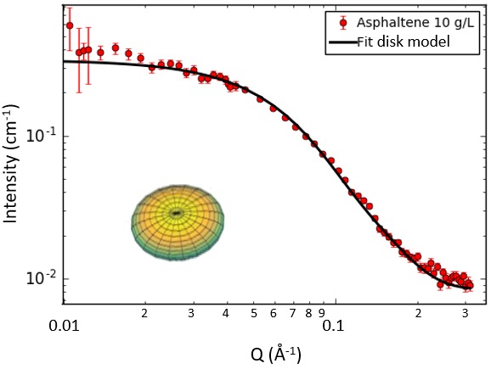 | 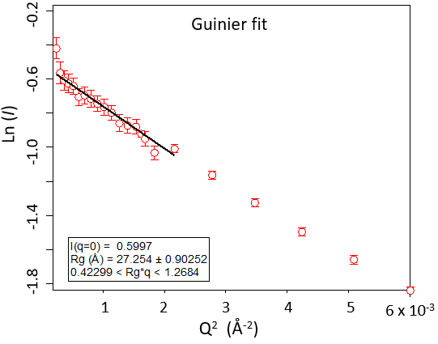

Figure 1. Determination of the nanoaggregate size of asphaltenes. Left: Scattering pattern and the fitting with a disk model. Right: using the Guinier fit with Ln I(Q)as a function of Q². System: [Asphaltenes]=10 g/L in D-toluene.

[Asphaltenes] g/L | Solvent | Guinier  Rg (Å) | Disk model |  | M_{w}  g/mol | N_{agg}
 |  |  | Radius (Å) | Height (Å)
10 | D-toluene | 28.7±1.5 | 31.0±1 | 20.6±1 | 14400±400 | 19±1
10 | 25/75 % v/v D-heptane/D-toluene | 28.3±1.5 | 31.8±1 | 21.2±1 | 13700±400 | 18±1
10 | 50/50 % v/v D-heptane/D-toluene | 35.3±1.5 | 39.2±1 | 21.1±1 | 25300±500 | 34±1
2.5 | D-toluene | 31.5±2 | u | u | u | u

Table 1. Size of asphaltene nanoaggregates calculated with the Guinier and disk model equations (equations 3 and 4) and measured in various solvents and concentrations. u: not reported due to large uncertainties in the disk model. Also shown is the molecular weight calculated as explained in the text and the corresponding aggregation number for the nanoaggregates.

Influence of Asphaltene Solvency
The size of asphaltene nanoaggregates were determined in different solvency conditions, i.e. by adding different an amount of D-heptane but still below the precipitation onset⁴⁹. The scattering patterns of 10 g/L asphaltenes in D-toluene, and in 25/75 % v/v and 50/50 % v/v D-heptane/D-toluene mixed solvents are presented in Figure 2. It can be seen that the scattering pattern is similar in D-toluene and in 25/75 % v/v D-heptane/D-toluene, which means that the nanoaggregates are similar in both media. On the contrary, in presence of 50 % D-heptane, the scattering intensity significantly increases, meaning that the asphaltene nanoaggregates have grown in size. The superimposition of scattered intensity in the high Q region (Q > 0.1 Å), in pure toluene and in mixture of toluene of heptane, indicates that the internal structure of the asphaltene aggregates does not depend on the solvent. The sizes extracted from the scattering patterns and summarized in Table 1 confirm the trend observed in Figure 2. Indeed, the radius of gyration of asphaltene nanoaggregates remains near constant in presence of 25 % v/v D-heptane (28.7 Å in D-toluene vs. 28.3 Å in 25/75 % v/v D-heptane/D-toluene) and significantly increases in 50 % v/v D-heptane (35.3 Å). However, even if it increases, the radius is still in the nanometre range, thus only moderate additional aggregation takes place. Similar observations can be done with the sizes calculated from the disk model, especially by looking at the radius values. These results are consistent with the observations by Fenistein et al.³⁹, Spiecker et al. (below the precipitation onset)⁴¹ and Hoepfner et al.^{67, 68}. For instance, Hoepfner et al.⁶⁸ have observed that the radius of gyration and the molecular weight of asphaltenes from 4 different oils in toluene-heptane solvent increases with the heptane content up to a maximum, and then decreases. Rg values vary from ≈5 to 15 nm in pure toluene to ≈ 7 to 42 nm in toluene-heptane mixtures depending on the asphaltene sample.
In Table 1 are also shown the molecular weights (M_{w}) of the nanoaggregates, calculated from the relationship between M_{w} and the asymptotic crossing with the intensity axis, as previously used in our work on tetrameric acid⁶⁹. The crossing will also be proportional to the square of the difference in scattering length density between the particle and the solvent. For this calculation, the scattering length densities for the asphaltene (1.32 x 10⁻⁶ Å⁻²), D-toluene (5.66 x 10⁻⁶ Å⁻² ) and D-heptane (6.30 x 10⁻⁶ Å⁻²) were therefore used, together with the specific weight of 1.15 g/cm³ for asphaltene. From the molecular weight of the aggregate, the aggregation number (N_{agg}) can also be calculated given the molecular weight of an asphaltene molecule. Using the value of 750 g/mol determined by Groenzin and Mullins^{19, 20}, we find that N_{agg} increases from ca. 19 in D-toluene to 34 in the 50/50 D-heptane/D-toluene mixture.

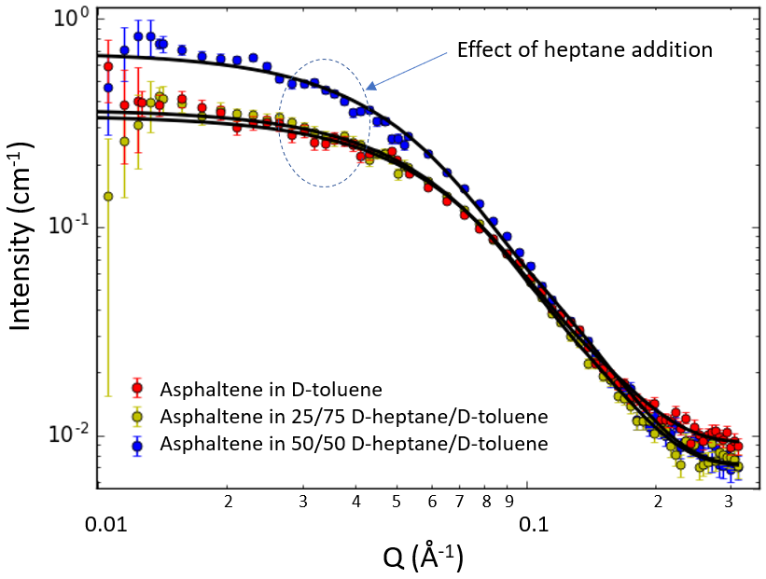
Figure 2. Influence of D-heptane on the scattering pattern of asphaltenes. System: [Asphaltenes]=10 g/L in D-toluene, 25/75 % v/v, and 50/50 % v/v D-heptane/D-toluene mixed solvents. The contribution of solvents has been subtracted from the intensities.

Asphaltene Conformation at Solid Surfaces

Determination of adsorbed amounts using QCM
QCM is a classical technique to characterize adsorption of asphaltenes onto solid surfaces. This technique allows to determine the adsorbed amount, a parameter that can also be determined from the analysis of neutron reflectometry data. Consequently, values obtained from QCM will be used to test the validity of the neutron reflectometry results.
Table 2 presents the adsorbed mass after 1 h adsorption, Γ_{ads}, and after 30 minutes of desorption in toluene, Γ_{des}, i.e. the amount of asphaltenes still present on the crystal after replacing the asphaltene solution in the cell by pure toluene. The amount of asphaltene adsorbed onto silica surfaces (3.28 mg/m²) and the desorption (19 %, based on Γ_{des} = 2.65 mg/m²) are typical of values found in the case of adsorption of asphaltenes in good solvent like toluene or xylene onto polar surfaces^{16, 70}. The pluronic adsorbed amount (1.57 mg/m²) is significantly lower than for asphaltenes. The value is, however, significantly higher than measured by the depletion method on silica particles by Shar et al.⁷¹ These authors found values between 0.06 and 0.235 mg/m² depending on the pluronic structure, but the solvent was different (water) which could explain the difference in the extent of adsorption.
When asphaltenes and pluronic are present in the same solution, the extent of adsorption is intermediate between pure pluronic and pure asphaltenes, meaning that the adsorbed layer is composed of a mixture of asphaltenes and pluronic. Unfortunately, it is not possible to determine the relative contribution of the two compounds from QCM data.

System | Γ_{ads} (mg/m²) | Γ_{des} (mg/m²)
Pluronic 0.1 g/L | 1.57 +/- 0.12 | 1.06 +/- 0.08
Asphaltenes 2 g/L | 3.28 +/- 0.18 | 2.56 +/- 0.23
Pluronic 0.1 g/L + Asphaltenes 2 g/L | 2.65 +/- 0.18 | 1.98 +/- 0.13

Table 2. Determination of adsorbed amount (n=5) onto silica surface by QCM after 1 hour of adsorption, Γ_{ads,} followed by 30 minutes of desorption with pure toluene, Γ_{des}. The error bars represent the range of values obtained.

Neutron reflectometry study
In this section, the asphaltene layer is studied by neutron reflectometry. Neutron reflectometry is a powerful technique to determine the layer structure on flat surfaces. To our knowledge, this technique has only been applied two times previously to characterize asphaltene. Jouault et al.⁷² have studied the influence of the solvent composition on the adsorption of asphaltenes onto hydrophilic and hydrophobic silicon wafers, while Corvis et al.⁷³ have determined the influence of the shear rate on the adsorption of asphaltenes.
Two neutron reflectometry measurement series were performed, with different objectives: The internal structure of the asphaltene layer was determined by varying the scattering length density of the solvent (section 3.2.3) through measurements at RAL, and the influence of a model demulsifier (pluronic PE 8100) on the adsorption of asphaltenes was determined via measurements at PSI (section 3.2.4).
The analysis of the data was performed by using the scattering length densities summarized in Table 3. The scattering length density (SLD), which determines the neutron scattering contrast, is given by the expression SLD=(1/v_{m})Σb_{i}, where b_{i} is the coherent scattering length of a specific atom in a molecule and v_{m} the molecular volume. The SLD of asphaltenes was calculated from its elemental composition and density. This density (1.154 g/cm³) was determined by extrapolating to 100 % asphaltenes the variations of 1/density of asphaltene solutions in xylene measured with a densitometer DMA 5000 (Anton Paar).

Material | SLD (10⁻⁶ Å⁻²)
D-toluene | 5.66
H-toluene | 0.94
SiO₂ | 3.47
Si | 2.07
Asphaltenes | 1.32
Pluronic | ∼0.5

Table 3. Scattering length densities of the materials investigated.

Conformation of asphaltenes determined by contrast variations
The first part of the neutron analysis consisted in analyzing the data obtained by the contrast variation method used at RAL. The constraints on fitting of multiple curves measured on the same system but at various D-toluene/H-toluene ratios allowed to obtain a robust determination of the properties of the interface. The procedure was confirmed by observing that the fitting converged to the same parameters independent of the initial guess.
The contrast variation method consists in determining the reflectivity curves of the asphaltene layer by varying the contrast between asphaltenes and the solvent, i.e. by changing the D-toluene/H-toluene ratio. In practice, the procedure used was to inject into the silicon wafer-containing cell asphaltene solutions at the same concentration but with different D-toluene/H-toluene ratios. The injection procedure was checked by measuring the density of the solution recovered at the end of the exchange period d_{m}. Its mass fraction in D-toluene φ_{m-D-tol} was calculated from d_{m} and the density of pure D-toluene d_{D-tol} and H-toluene d_{H-tol} measured beforehand using the relationship:

$$ϕ_{m-D-tol}=\frac{\frac{1}{d_{m}}-\frac{1}{d_{H-tol}}}{\frac{1}{d_{D-tol}}-\frac{1}{d_{H-tol}}}$$ (6)

The mass fraction in D-toluene calculated by means of equation 6 corresponded exactly to the prepared solutions (maximum difference in mass fraction of 7×10⁻³), which validates the exchange procedure.
The reflectivity curves for pure D-toluene and solutions of asphaltenes (2 g/L) in mixtures of D-toluene and H-toluene are presented in Figure 3, given as logarithm of RQ⁴ as a function of Q, This representation is sometimes useful for neutron reflectivity as it allows to visualize better the differences between systems, which can otherwise be difficult owing to the fast Q⁻⁴ decay of the Fresnel reflectivity of the pure silicon/deuterated solvent interface.
The reflectivity of asphaltene solutions with a specific D-toluene/H-toluene volume ratio depends principally on the scattering length density difference between the silicon layer (SLD=2.07×10⁻⁶ Å⁻²) and the solvent. The overall reflectivity is at its lowest for 24 % v/v D-toluene when the SLD of the solvent and the silicon layer match. The reflectivity is at its highest in pure D-toluene since the contrast is maximum between the silicon layer and the solvent (Table 3).

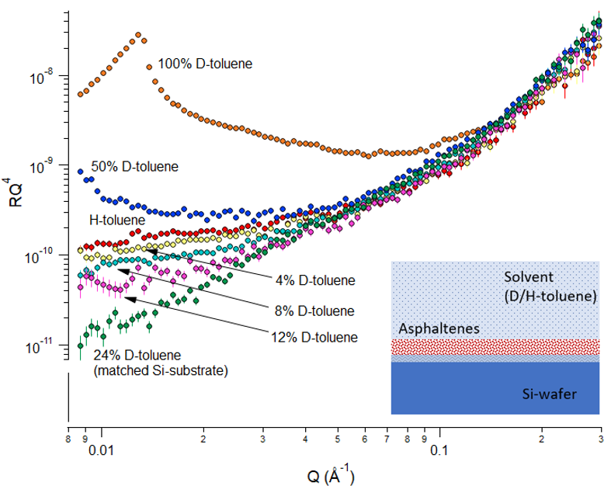
Figure 3. Reflectivity curves plotted in the form of RQ⁴ as a function of Q for pure solutions of asphaltenes (2 g/L) in mixtures of D-toluene and H-toluene. The volume fraction in D-toluene is indicated on the curves. The data has been normalized, but not background-subtracted.

The analysis of the data first started by determining the characteristics of the oxide layer on top of silicon. The analysis was performed by fitting the reflectivity curves of the silicon wafer measured in pure D-toluene in absence of asphaltenes (see inset in Figure 4). In this situation, the reflectivity curve allows to determine the thickness and the roughness of the silicon oxide layer.
The obtained value of 13 Å for the thickness is typical of values found by other research groups for similar silicon oxide layers^{72, 74, 75}, even if the oxidative treatment can be different (sulfuric acid and hydrogen peroxide for Jouault et al. or no surface treatment for Penfold et al.). The roughness was found to be 10 Å for this system, also in the range typically found by others. Note that this corresponds to the roughness at the SiO₂ / asphaltene interface when asphaltene is present in the sample cell. These values were employed as starting inputs in the model used to fit the reflectivity curves in presence of asphaltenes and/or pluronic. There is also a small roughness for the pure silicon below the oxide layer. The roughness was fixed to a value of 3 Å, in accordance with specifications provided by the manufacturer. It should be noted that for relatively thin layers of adsorbed material, as expected in the present case for asphaltene, a correct determination of the properties of the SiO₂ layer is critical for the evaluation of the thickness and roughness of the adsorbed layer, since the final result will be very sensitive to the SiO₂ parameters. This sensitivity is due to the fact that the different contributions may be of similar size and are convoluted in the final scattering pattern.
A simultaneous fit of all the datasets that contained asphaltene (2 g/L) with different D-toluene/H-toluene ratios was made using the GenX-platform, coupling together the parameters that were unchanged while varying the SLD-values as given by the exact D/H-ratios for the solutions. The latter were determined via the known SLD-values for D-toluene (5.66 · 10⁻⁶Å⁻²) and pure H-toluene (0.94 · 10⁻⁶Å⁻²). In this manner we could strongly constrain the parameters and avoid false minima in the fitting. Note also that since we had previously determined the chemical composition of this asphaltene by elemental analysis, we could fix the SLD of asphaltene to the calculated value of 1.32 · 10⁻⁶Å⁻². This approach allowed us to also determine accurately the degree of solvent penetration into the asphaltene (solvation). The fitted data are shown in Figure 4, with the numerical results in Table 4. Here the values of thickness and roughness for the silicon oxide layer are also included.

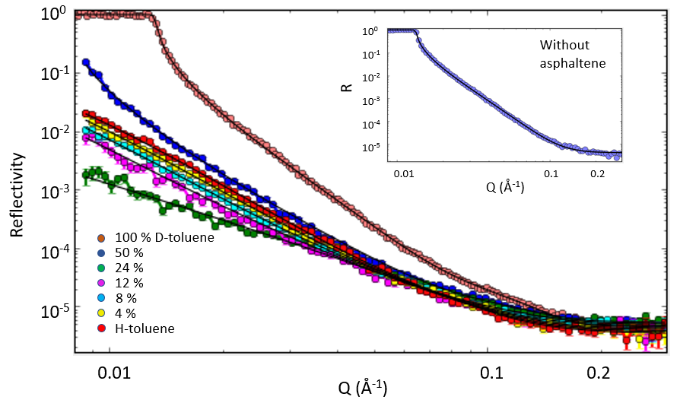

Figure 4. Reflectivity curves in the form of log R vs. log Q as a function of Q for solutions of asphaltenes (2 g/L) in mixtures of D-toluene and H-toluene. The volume fraction in D-toluene for the different samples are indicated. The continuous lines represent the model fits. Inset: Reflectivity data and model fit for the sample without asphaltene, i.e. Si-wafer and D-toluene only. The data has been normalized, but not background-subtracted. The model curves include background values used in the fitting.

Asphaltene thickness | Asphaltene roughness | Solvation | SiO₂ thickness | SiO₂ roughness
51.4 ± 1 Å | 7.3 ± 0.5 Å | 91 ± 1 % | 13.3 ± 0.5 Å | 10.1 ± 0.5 Å

Table 4. Thickness, roughness and degree of solvent penetration for the adsorbed asphaltene (2 g/L). Values for the SiO₂ layer are also given. The figure of merit (FOM) for the simultaneous fitting was 0.034.

The thickness we find (51 Å) corresponds quite well with the diameter found earlier from bulk measurements (with SANS) on these samples, where the nanoaggregate radius was found to be ca. 30 Å, thus an approximate diameter of 60 Å. However, the value is a bit lower, and this might be expected if there is a slight compression of the nanoaggregates due to the adherence to the hydrophilic surface. Jestin et al.⁵² also found by SANS that the asphaltene layer stabilizing water-in-toluene emulsions has a thickness that is very close to twice the radius of gyration of the aggregates in solution (for asphaltenes respectively precipitated in pentane, heptane, and octane, the radius of gyration are 66, 84, and 106 Å, and the thicknesses are 113, 135, and 149 Å). This relationship could mean that the extent of the asphaltene layer is linked to its self-associative properties in bulk. The thickness found in the present study is lower than the values obtained by Jouault et al. and Corvis et al. ^{72, 73} from neutron reflectometry (62 to 87 Å depending on the resin content in the asphaltene sample). The thickness is also lower than values found by SANS in model w/o emulsions (100-150 Å) ^{52, 53}. Adsorbed layer thicknesses deduced from surface-force-apparatus (SFA) measurement on bitumen asphaltene adsorbing onto silica surfaces in toluene are also higher. Indeed, Wang et al.⁷⁶ found that the thickness (half the hard wall distance value) of the asphaltene layer increases from ≈ 60 - 75 Å to 300 Å after respectively 2 hours and 20 hours of adsorption. Sztukowski et al.⁷⁷ have studied the adsorption of asphaltenes onto water droplets by measuring the variations of the asphaltene adsorbed amount on water droplets and the molar mass of asphaltene aggregates in solution as a function of asphaltene concentration. They conclude that asphaltenes form aggregate monolayers at the liquid/liquid interface. They also calculated asphaltene film thickness values ranging from 20 to 90 Å by assuming a cylindrical shape for adsorbed asphaltene molecules.
The difference between thickness values could perhaps be linked to the variability in asphaltene structure with their origin and their preparation method (presence of resins). In general, all asphaltenes present similar behavior/properties (nanoaggregation, flocculation, adsorption), but the extent of these properties depends on their origin. For instance, Simon et al. have reported large variations of asphaltene nanoaggregate size in bulk depending on the crude oil origin, the preparation method (n-alkane used), and the solvent⁴⁰.
The roughness of the asphaltene layer towards the solvent was found to be 7.3 Å. This value is relatively low, but it could still indicate a slight irregularity over the surface, or regions of dangling chains into the solvent.
It is interesting to note that the solvation is found to be very high, i.e. 91%. This value is however in line with the values reported by Jestin et al.⁵² and Verruto and Kilpatrick⁵³ in their characterizations of the asphaltene layers around water droplets by SANS, where asphaltene volume fractions of 10-20 % are mentioned. However, one can gain a bit more information by plotting the calculated SLD-profile versus distance. This plot is shown in Fig. 5 for the case of asphaltene in pure D-toluene. The main part of the asphaltene region is seen to have an SLD-value slightly above 5, corresponding to a solvation of around 90 % as mentioned above), and thus an asphaltene concentration of about 10 %. However, the SLD-value is seen to drop considerably as one approaches the SiO₂ surface, which is equivalent to a lower degree of solvation. The percentage of asphaltene can be estimated via linear interpolation between the value of pure asphaltene (SLD=1.32 ·10⁻⁶ Å⁻²) and that of pure D-toluene (SLD=5.66 · 10⁻⁶ Å⁻²), which leads to an approximate asphaltene concentration of 71 % (i.e. 29 % solvation) for the region closest to the SiO₂ surface. These results therefore indicate that there is a significant reduction in asphaltene solvation the first 15-20 Å from the surface. Note however, that this estimate is based on the somewhat simplistic picture of the asphaltene layer starting at the position where the SLD has reached the value referred to above for pure asphaltene. The named regions correspond with the thicknesses found for each layer (SiO₂ and asphaltene). In practice the interfaces are governed by the surface roughness in the model. The values noted for the asphaltene concentration are therefore rough indications, where the main point is rather the tendency of a low solvation near the surface and gradually increasing solvation away from the surface. Another point to mention is that within the experimental error of the data it would be possible to assume another mathematical function (e.g. non-smooth or non-sigmoidal) to represent the interface region with similar final χ²-values for the fitting. However, the information content of a reflectivity experiment is generally insufficient to divert from the established mathematical presentation of surface roughness that gives the transition region in the diagram. In summary this means that there is a significant uncertainty with the local asphaltene concentrations shown in Fig. 5. The amount is difficult to calculate, but is likely on the order of ±5% or more. This value is a rough estimate made by following the displacement of the SLD-curve when entering different values for the thickness of the interface zone (roughness) between the asphaltene and the SiO2 surface. A 50 % change in the roughness in both directions from the fitted value, produced a displacement in the SLD-curve corresponding to a 5% change in the asphaltene concentration at a position halfway into the asphaltene layer.
One slightly surprising feature of the SLD curves is the dip in SLD outside the layer we have designated SiO₂. In neutron reflectivity, one does not obtain atomic information, thus the designation SiO₂ is solely a label. However, we do expect a layer since a Si (111) surface is not stable in air, and we generally see a native oxide layer forming which is around 10-30 Å on a silicon surface. This layer would however have a higher SLD than bulk Si. The observed low SLD value thus deserves some consideration. Anecdotally, such a layer is not unheard of when investigating oils (or even water) using neutron reflectivity, but its nature remains a subject of debate. One explanation is that the oleophobicity of the SiO₂ surface creates some form of “nano-bubbles”⁷⁸ at the surface. Another possible cause would be that any water existing in the solvent phase would naturally migrate to this surface, to form a very thin watery layer at the interface. Since hydrogen has a negative scattering length this would produce a drop in the SLD, and the required amounts of water are in the ppm range, thus very difficult to both measure and eliminate.
The SLD-profile presented in Figure 5 is somewhat different from the profiles obtained by Jouault et al.⁷². They report that they could not keep fixed values for the silica oxide layer when fitting the data. However, these authors calculated the SLD profiles from neutron reflectometry data obtained only in D-toluene. The profile presented in Figure 5 was determined from the simultaneous fit of several datasets measured at different D-toluene/H-toluene ratios that strongly constrained the results.

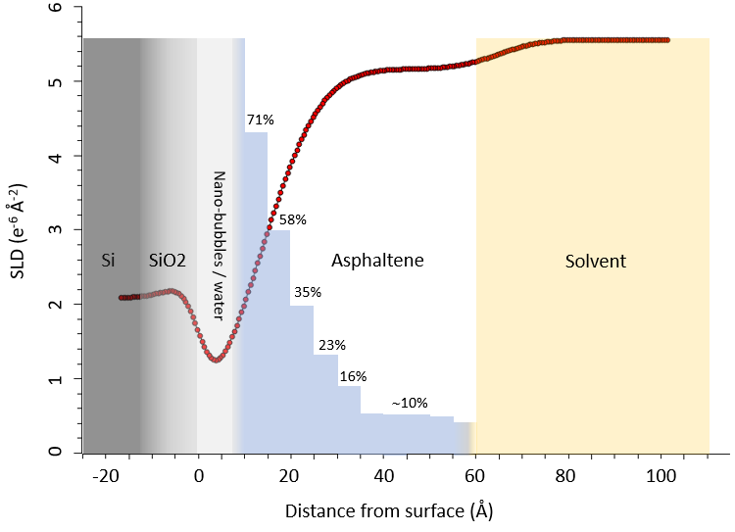
Figure 5. SLD-profile for asphaltene in D-toluene as function of distance from the silicon surface. The region named with each component in the figure is determined by the midpoints of the transitions between the neighboring layers, according to the definition in the fitting algorithm. An estimate of the amount of asphaltene (with respect to solvent) based on the SLD-value at different distances is shown as vertical bars.

By integrating the amount of asphaltene in different positions above the surface (as calculated from the SLD-profile in Figure 5) and using the known specific mass of asphaltene (1.15 g/cm3), one obtains a total coverage of 3.0 mg/m². This value compares well with the independent results from the QCM measurements presented in section 3.2.1.
Finally, the possibility of a "2-layer" asphaltene model was investigated. Such a situation might occur if the asphaltenes adsorbed as individual molecules with a specific preference for either the side chains or the aromatic regions being directed towards the surface. However, several variants of 2-layer models were tested on the present data, but they always converged with the second layer having zero thickness, independently of the starting values used for hydration and thicknesses of the two layers. This is a strong indication that we do not have a 2-layer structure for this system - a situation which can be expected if the asphaltene adsorbs mainly in the form of nanoaggregates already formed in solution and less in the form of individual molecules.
These neutron reflectivity measurements have allowed us to determine the concentration profile of the asphaltene layer in the perpendicular direction with respect to the silicon wafer. The presence and extent of lateral heterogeneities, such as patches or aggregates, cannot be determined from our measurements. Other techniques such as off-specular reflectometry ⁷⁹ or atomic force microscopy ⁸⁰ should be implemented to get such information.

Influence of pluronic on the asphaltene layer
The values obtained from the contrast variation experiment were subsequently used as initial parameters to analyze the data describing the influence of pluronic on asphaltene adsorption, measured at PSI. For these data, it was found that without this prior information about the asphaltene, several solutions could provide near similar quality of the fitting, resulting in contradictory descriptions of the asphaltene layer (flat adsorption of asphaltenes with no solvent penetration into the asphaltene (solvation) vs. thicker layers with 90 % of solvation for instance). This came from the limited constraint on the fitting since these systems were only measured in D-toluene and therefore the parameters were calculated from the fitting of a single curve.
Figure 6 presents the reflectivity curves, given as logarithm of RQ⁴ as a function of Q for asphaltene at 2 g/L in D-toluene, asphaltene at 2 g/L + pluronic at 0.1 g/L in D-toluene, as well as the pattern for pluronic at 0.1 g/L in D-toluene. In the figure is also shown as inset the curve for D-toluene only.
The reflectivity curves in presence of asphaltenes and/or pluronic present some variations compared with the wafers measured in pure D-toluene. Specifically, there is an added contribution to the reflectivity pattern in the range above ca. Q=0.05 Å⁻¹. This highlights the presence of an adsorbed layer on top of the silicon. There are also some differences in the reflectivity patterns between the investigated systems, which could be used to extract thickness and roughness values by least-squares fitting and compare their variations. As mentioned previously, the methodology used to fit a reflectivity curve measured only in D-toluene without varying the D-toluene/H-toluene ratio is quite critical. It was found that different combinations of parameters, i.e. both low/high solvation vs. high/low thickness and roughness, could give reasonable fits depending on the initial guess entered in the fitting routine. For this reason, the fitting of reflectivity curves obtained in D-toluene were performed by using as reference the parameters calculated previously in the multi-contrast study. The fitting of systems containing pluronic were also analyzed by constraining the solvation, assuming a high value (> 90 %) even if these systems were not previously analyzed with the contrast variation method, since their reflectivity variations are relatively close to that of asphaltene. Similarly to in section 3.2.3, the characteristics of the silicon oxide layer were first determined from the reflectivity curve measured in D-toluene and in absence of asphaltenes or pluronic. These characteristics were then used as inputs to fit the reflectivity curves in presence of asphaltenes and/or pluronic. The model curves are included in the plots in Figure 6, and the characteristics of the adsorbed layer for the different systems are presented in Table 5. It should be noted, however, that the error bars are relatively large for these values due to fact that this is not a contrast variation study.

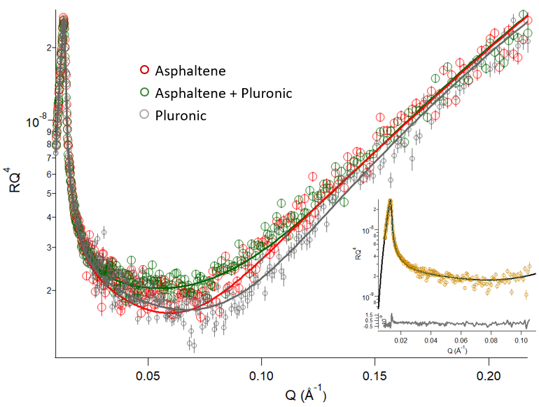

Figure 6. Reflectivity curves RQ⁴ as a function of Q and model curves (continuous lines) for asphaltenes at 2 g/L , asphaltenes at 2 g/L + pluronic at 0.1 g/L, and only pluronic at 0.1 g/L, all in D-toluene. The inset shows the pattern for the silicon wafer in d-toluene. The data has been normalized, but not background -subtracted. The model curves include background values used in the fitting.

From inspection of Figure 6, the differences are seen to be small, and between asphaltene and the mixture (asphaltene+pluronic) there is only a tiny difference visible in the range below Q=0.1 Å⁻¹. This observation shows directly that the effects of pluronic addition are quite small for this system. Based on the fitting, the pure asphaltene layer was found to have a thickness of ca. 47 Å with a relatively small roughness (4 Å). These values are similar to the ones found in the contrast matching experiments. We note that the asphaltene is found to have a high degree of solvation, above 90 %. Due to the signal-to-noise level of the data, this value cannot be determined very accurately. For the fitting to converge it was necessary to put limits on the solvation parameter, based on the results from the contrast variation experiment presented in the previous section.
The pluronic layer was found to have a smaller thickness of ca. 28 Å with a roughness of 6 Å. A size of 28 Å is equivalent to 18 C-C single bonds. Therefore, considering the molecular weight of the pluronic (2600 g/mol ⁵⁵), equivalent to 186 C-C bonds, that means that the pluronic chains are not protruding very far into the solvent and adopt a relatively flat conformation on silicon oxide. Shar et al. obtained similar conclusions by measuring the hydrodynamic thickness of pluronic adsorbed on silica particles in aqueous solution⁷¹. We note that the relative size of the pluronic layer with respect to that of the asphaltene (28 Å/47 Å) is quite close to the ratio of adsorbed amount of these compounds as found from the QCM data, indicating that the reflectometry and QCM experiments are comparable.
The layer formed with a mixed solution of asphaltenes and pluronic presents a slightly shorter layer thickness (39Å) than the pure asphaltene layer. This reduction indicates that the pluronic is partially incorporated into the asphaltene layer, although the interaction is weak. The percentage reduction of the thickness (17 %) is in good agreement with the reduction of the adsorbed amount when pluronic is present, as found from QCM (19 %).

System | Thickness (Å) | Roughness (Å) | Solvation (volume percent)
D-toluene (SiO₂ surface layer) | 13.9 | 7.9 | -
Asphaltenes 2 g/L | 47 | 4 | 94
Pluronic 0.1 g/L | 28 | 6 | 92
Asphaltenes 2 g/L + Pluronic 0.1 g/L * | 39 | 12 | 97

Table 5. Thickness, roughness and solvation degree for the various investigated systems obtained by fitting the reflectivity data presented in Figure 6. The errors in the fitted thickness and roughness are approx. 2.0 Å Solvent: D-toluene. *: For this sample the values are more uncertain because also the SLD-value was fitted (since the composition ratio between asphaltenes and pluronic inside the layer is not known).

It should be noted that for the mixed system of asphaltene and pluronic, the SLD was fitted to an approximate value of 1.2x10⁻⁶ Å⁻². This SLD is slightly lower than that of asphaltene (1.32x10⁻⁶ Å⁻²), and much higher than that of pure pluronic (0.5 ·10⁻⁶ Å⁻²). This difference demonstrates that the pluronic is only weakly incorporated into the asphaltene layer. The roughness of 12 Å found for this mixed layer (cf. Table 5) is a coarse value, i.e. with quite large uncertainty, due to the limited information content of the data when the exact SLD of the layer is not known a priori.

CONCLUSIONS
The use of two different neutron scattering techniques, SANS and neutron reflectometry, made it possible to study the behavior of the same source of asphaltenes both in solution (bulk) and when adsorbed onto a solid surface. The bulk measurements demonstrated that these asphaltenes tend to form nanoaggregates when dissolved in D-toluene, with an overall diameter of around 6 nm.
The reflectometry studies were performed using a contrast variation technique, whereby a series of D-toluene/H-toluene ratios were employed to change the scattering contrast between the solvent, the solid surface, and the adsorbed layer. This methodology turned out to be crucial to extract reliable values for the adsorbed asphaltene, particularly due to the high degree of solvent penetration for this asphaltene. An asphaltene thickness of 51 Å and roughness of 7 Å, as well as an average solvation of 91 % was found in this study. This asphaltene thickness corroborates a situation where nanoaggregates from the solution adsorb onto the silicon surface - possibly due to some unshielded polar entities interacting with the hydrophilic surface, as shown by dissipative particle dynamics (DPD) simulation results⁸¹ - and where the aggregates become moderately compressed in the process. The high degree of solvation is in accord with indirect results obtained by Jestin et al. on a different asphaltene source. On the other hand, one cannot exclude that this value, which is an average over the surface, might be due partly to some areas not being fully covered by asphaltene (thus containing mainly solvent). Such a situation will also affect the average surface roughness, that was here measured to 7 Å. It should furthermore be noted that the SLD-curve extracted from the fitting indicate a lower degree of solvation of the asphaltene close to the surface.
Finally, the adsorption onto a hydrophilic surface of the model demulsifier pluronic in combination with asphaltene was studied. The pluronic alone shows a significantly weaker surface adsorption than asphaltene. Furthermore, when pluronic is added (0.1 g/L), the thickness of the adsorbed asphaltene layer is reduced with approximately 17 %, showing the demulsifying effect of pluronic. These results were also in good accordance with data obtained independently from QCM measurements.
To conclude, this study has provided a better description of the properties of the asphaltene layer and the effect of a model demulsifier on it. As far as the authors of the present study are concerned, this description could be used to constrain models aiming to simulate crude oil interfaces⁸² to understand and improve oil-water separation process in the crude oil industry.

AUTHOR INFORMATION
Corresponding Author
* Tel.: (+47) 73 59 16 57. Fax: (+47) 73 59 40 80. E-mail: sebastien.simon@chemeng.ntnu.no

ACKNOWLEDGEMENT

The authors thank the JIP Electrocoalesence consortium “New Strategy for Separation of Complex Water-in-Crude Oil Emulsions: From Bench to Large Scale Separation”, consisting of Ugelstad Laboratory (NTNU, Norway), University of Alberta (Canada), Swiss Federal Institute of Technology in Zurich (Switzerland), and Institute for Energy Technology (IFE, Norway) and funded by Norwegian Research Council (Petromaks II Grant 255174) and the following industrial sponsors: Anvendt Teknologi AS, Equinor, NalcoChampion, Nouryon, and Sulzer. This work is based on experiments performed at the Swiss spallation neutron source SINQ, Paul Scherrer Institute, Villigen PSI, Switzerland, and at the ISIS Neutron and Muon Source, UK. Experiments at SINQ were supported by beamtime allocation 20170059. Experiments at the ISIS Neutron and Muon Source were supported by a beamtime allocation RB1820191 from the Science and Technology Facilities Council (DOI: 10.5286/ISIS.E.98000988). The authors thank Einar Eng Johnsen (Equinor) for his comments on the manuscript.

REFERENCES

1. Fakhru’l-Razi, A.; Pendashteh, A.; Abdullah, L. C.; Biak, D. R. A.; Madaeni, S. S.; Abidin, Z. Z., Review of technologies for oil and gas produced water treatment. Journal of Hazardous Materials 2009, 170, (2–3), 530-551.
2. Eow, J. S.; Ghadiri, M., Electrostatic enhancement of coalescence of water droplets in oil: a review of the technology. Chemical Engineering Journal 2002, 85, (2–3), 357-368.
3. Eow, J. S.; Ghadiri, M.; Sharif, A. O.; Williams, T. J., Electrostatic enhancement of coalescence of water droplets in oil: a review of the current understanding. Chemical Engineering Journal 2001, 84, (3), 173-192.
4. Less, S.; Hannisdal, A.; Bjørklund, E.; Sjöblom, J., Electrostatic destabilization of water-in-crude oil emulsions: Application to a real case and evaluation of the Aibel VIEC technology. Fuel 2008, 87, (12), 2572-2581.
5. Al-Sabagh, A. M.; Kandile, N. G.; Noor El-Din, M. R., Functions of Demulsifiers in the Petroleum Industry. Separation Science and Technology 2011, 46, (7), 1144-1163.
6. Sjöblom, J.; Aske, N.; Harald Auflem, I.; Brandal, O.; Erik Havre, T.; Saether, O.; Westvik, A.; Eng Johnsen, E.; Kallevik, H., Our Current Understanding of Water-in-Crude Oil Emulsions.: Recent Characterization Techniques and High Pressure Performance. Adv. Colloid Interface Sci. 2003, 100-102, 399-473.
7. Grutters, M.; van Dijk, M.; Dubey, S.; Adamski, R.; Gelin, F.; Cornelisse, P., Asphaltene Induced W/O Emusilon: False or True? J. Dispersion Sci. Technol. 2007, 28, (3), 357-360.
8. Sjöblom, J.; Simon, S.; Xu, Z., Model molecules mimicking asphaltenes. Advances in Colloid and Interface Science 2015, 218, (0), 1-16.
9. Hanneseth, A.-M. D.; Selsbak, C.; Sjöblom, J., Behavior and Stability of Naphthenic Acid/Naphthenate Stabilized Emulsions. Mixed C80-Tetraacid and Stearic Acid Stabilization. Journal of Dispersion Science and Technology 2010, 31, (6), 770-779.
10. Arla, D.; Sinquin, A.; Palermo, T.; Hurtevent, C.; Graciaa, A.; Dicharry, C., Influence of pH and Water Content on the Type and Stability of Acidic Crude Oil Emulsions. Energy Fuels 2007, 21, (3), 1337-1342.
11. Ese, M. H.; Kilpatrick, P. K., Stabilization of Water-in-Oil Emulsions by Naphthenic Acids and Their Salts: Model Compounds, Role of pH, and Soap:Acid Ratio. J. Dispersion Sci. Technol. 2004, 25, (3), 253-261.
12. Sullivan, A. P.; Kilpatrick, P. K., The Effects of Inorganic Solid Particles on Water and Crude Oil Emulsion Stability. Ind. Eng. Chem. Res. 2002, 41, (14), 3389-3404.
13. Hannisdal, A.; Ese, M.-H.; Hemmingsen, P. V.; Sjoblom, J., Particle-stabilized emulsions: Effect of heavy crude oil components pre-adsorbed onto stabilizing solids. Colloids Surf., A 2006, 276, (1-3), 45-58.
14. Kralova, I.; Sjöblom, J.; Øye, G.; Simon, S.; Grimes, B. A.; Paso, K., Heavy Crude Oils/Particle Stabilized Emulsions. Advances in Colloid and Interface Science 2011, 169, (2), 106-127.
15. Speight, J. G., Petroleum Asphaltenes - Part 1: Asphaltenes, Resins and the Structure of Petroleum Oil & Gas Science and Technology 2004, 59, (5), 467-477
16. Subramanian, S.; Simon, S.; Gao, B.; Sjöblom, J., Asphaltene fractionation based on adsorption onto calcium carbonate: Part 1. Characterization of sub-fractions and QCM-D measurements. Colloids and Surfaces A: Physicochemical and Engineering Aspects 2016, 495, 136-148.
17. Subramanian, S.; Sørland, G. H.; Simon, S.; Xu, Z.; Sjöblom, J., Asphaltene fractionation based on adsorption onto calcium carbonate: Part 2. Self-association and aggregation properties. Colloids and Surfaces A: Physicochemical and Engineering Aspects 2017, 514, 79-90.
18. Groenzin, H.; Mullins, O. C., Asphaltene Molecular Size and Structure. J. Phys. Chem. A 1999, 103, (50), 11237-11245.
19. Groenzin, H.; Mullins, O. C., Molecular Size and Structure of Asphaltenes from Various Sources. Energy & Fuels 2000, 14, (3), 677-684.
20. Groenzin, H.; Mullins, O. C., Molecular Size and Structure of Asphaltenes. Petroleum Science and Technology 2001, 19, (1-2), 219-230.
21. Groenzin, H.; Mullins, O. C.; Eser, S.; Mathews, J.; Yang, M. G.; Jones, D., Molecular Size of Asphaltene Solubility Fractions. Energy Fuels 2003, 17, (2), 498-503.
22. Hortal, A. R.; Martínez-Haya, B.; Lobato, M. D.; Pedrosa, J. M.; Lago, S., On the determination of molecular weight distributions of asphaltenes and their aggregates in laser desorption ionization experiments. Journal of Mass Spectrometry 2006, 41, (7), 960-968.
23. Pomerantz, A. E.; Hammond, M. R.; Morrow, A. L.; Mullins, O. C.; Zare, R. N., Two-Step Laser Mass Spectrometry of Asphaltenes. Journal of the American Chemical Society 2008, 130, (23), 7216-7217.
24. Pomerantz, A. E.; Hammond, M. R.; Morrow, A. L.; Mullins, O. C.; Zare, R. N., Asphaltene Molecular-Mass Distribution Determined by Two-Step Laser Mass Spectrometry†. Energy & Fuels 2008, 23, (3), 1162-1168.
25. Mitra-Kirtley, S.; Mullins, O. C.; Van Elp, J.; George, S. J.; Chen, J.; Cramer, S. P., Determination of the nitrogen chemical structures in petroleum asphaltenes using XANES spectroscopy. Journal of the American Chemical Society 1993, 115, (1), 252-258.
26. Simon, S.; Nenningstand, A. L.; Herschbach, E.; Sjoblom, J., Extraction of Basic Components from Petroleum Crude Oil. Energy & Fuels 2010, 24, 1043-1050.
27. Speight, J. G., The Chemistry and Technology of Petroleum, 4th Edition. CRC Press: 2007.
28. Murgich, J., Molecular Simulation and the Aggregation of the Heavy Fractions in Crude Oils. Molecular Simulation 2003, 29, (6-7), 451-461.
29. Schuler, B.; Meyer, G.; Peña, D.; Mullins, O. C.; Gross, L., Unraveling the Molecular Structures of Asphaltenes by Atomic Force Microscopy. Journal of the American Chemical Society 2015, 137, (31), 9870-9876.
30. Mullins, O. C., The Modified Yen Model. Energy & Fuels 2010, 24, (4), 2179-2207.
31. Chacón-Patiño, M. L.; Rowland, S. M.; Rodgers, R. P., Advances in Asphaltene Petroleomics. Part 3. Dominance of Island or Archipelago Structural Motif Is Sample Dependent. Energy & Fuels 2018, 32, (9), 9106-9120.
32. Fenistein, D.; Barre, L.; Frot, D., From Aggregation to Flocculation of Asphaltenes, a Structural Description by Radiation Scattering Techniques. Oil & Gas Science and Technology 2000, 55, (1), 123-128
33. Anisimov, M. A.; Yudin, I. K.; Nikitin, V.; Nikolaenko, G.; Chernoutsan, A.; Toulhoat, H.; Frot, D.; Briolant, Y., Asphaltene Aggregation in Hydrocarbon Solutions Studied by Photon Correlation Spectroscopy. The Journal of Physical Chemistry 1995, 99, (23), 9576-9580.
34. Wang, X.; Zhang, R.; Liu, L.; Qiao, P.; Simon, S.; Sjöblom, J.; Xu, Z.; Jiang, B., Interactions of Polyaromatic Compounds. Part 2. Flocculation Probed by Dynamic Light Scattering and Molecular Dynamics Simulation. Energy & Fuels 2017, 31, (9), 9201-9212.
35. Eyssautier, J.; Frot, D.; Barré, L., Structure and Dynamic Properties of Colloidal Asphaltene Aggregates. Langmuir 2012, 28, (33), 11997-12004.
36. Barre, L.; Simon, S.; Palermo, T., Solution Properties of Asphaltenes. Langmuir 2008, 24, 3709-3717.
37. Espinat, D.; Fenistein, D.; Barre, L.; Frot, D.; Briolant, Y., Effects of Temperature and Pressure on Asphaltenes Agglomeration in Toluene. A Light, X-ray, and Neutron Scattering Investigation. Energy Fuels 2004, 18, (5), 1243-1249.
38. Fenistein, D.; Barre, L., Experimental measurement of the mass distribution of petroleum asphaltene aggregates using ultracentrifugation and small-angle X-ray scattering. Fuel 2001, 80, (2), 283-287.
39. Fenistein, D.; Barre, L.; Broseta, D.; Espinat, D.; Livet, A.; Roux, J. N.; Scarsella, M., Viscosimetric and Neutron Scattering Study of Asphaltene Aggregates in Mixed Toluene/Heptane Solvents. Langmuir 1998, 14, (5), 1013-1020.
40. Simon, S.; Jestin, J.; Palermo, T.; Barre, L., Relation between Solution and Interfacial Properties of Asphaltene Aggregates. Energy & Fuels 2009, 23, (1), 306-313.
41. Spiecker, P. M.; Gawrys, K. L.; Kilpatrick, P. K., Aggregation and solubility behavior of asphaltenes and their subfractions. Journal of Colloid and Interface Science 2003, 267, (1), 178-193.
42. Spiecker, P. M.; Gawrys, K. L.; Trail, C. B.; Kilpatrick, P. K., Effects of petroleum resins on asphaltene aggregation and water-in-oil emulsion formation. Colloids and Surfaces A: Physicochemical and Engineering Aspects 2003, 220, (1-3), 9-27.
43. Roux, J. N.; Broseta, D.; Deme, B., SANS Study of Asphaltene Aggregation: Concentration and Solvent Quality Effects. Langmuir 2001, 17, (16), 5085-5092.
44. Fossen, M.; Kallevik, H.; Knudsen, K. D.; Sjöblom, J., Asphaltenes Precipitated by a Two-Step Precipitation Procedure. 1. Interfacial Tension and Solvent Properties. Energy & Fuels 2007, 21, (2), 1030-1037.
45. Dickie, J. P.; Yen, T. F., Macrostructures of the asphaltic fractions by various instrumental methods. Analytical chemistry 1967, 39, (14), 1847-1852.
46. Mullins, O. C.; Sabbah, H.; Eyssautier, J.; Pomerantz, A. E.; Barré, L.; Andrews, A. B.; Ruiz-Morales, Y.; Mostowfi, F.; McFarlane, R.; Goual, L.; Lepkowicz, R.; Cooper, T.; Orbulescu, J.; Leblanc, R. M.; Edwards, J.; Zare, R. N., Advances in Asphaltene Science and the Yen–Mullins Model. Energy & Fuels 2012, 26, (7), 3986-4003.
47. Pfeiffer, J. P.; Saal, R. N. J., Asphaltic bitumen as colloid system. Journal of Physical Chemistry 1940, 44, 139-149.
48. Eyssautier, J.; Levitz, P.; Espinat, D.; Jestin, J.; Gummel, J.; Grillo, I.; Barré, L., Insight into Asphaltene Nanoaggregate Structure Inferred by Small Angle Neutron and X-ray Scattering. The Journal of Physical Chemistry B 2011, 115, (21), 6827-6837.
49. Subramanian, S.; Simon, S.; Sjöblom, J., Interaction between asphaltenes and fatty-alkylamine inhibitor in bulk solution. Journal of Dispersion Science and Technology 2018, 39, (2), 163-173.
50. Teklebrhan, R. B.; Ge, L.; Bhattacharjee, S.; Xu, Z.; Sjöblom, J., Probing Structure–Nanoaggregation Relations of Polyaromatic Surfactants: A Molecular Dynamics Simulation and Dynamic Light Scattering Study. The Journal of Physical Chemistry B 2012, 116, (20), 5907-5918.
51. Jian, C.; Tang, T.; Bhattacharjee, S., Probing the Effect of Side-Chain Length on the Aggregation of a Model Asphaltene Using Molecular Dynamics Simulations. Energy & Fuels 2013, 27, (4), 2057-2067.
52. Jestin, J.; Simon, S.; Zupancic, L.; Barre, L., A Small Angle Neutron Scattering Study of the Adsorbed Asphaltene Layer in Water-in-Hydrocarbon Emulsions: Structural Description Related to Stability. Langmuir 2007, 23, (21), 10471-10478.
53. Verruto, V. J.; Kilpatrick, P. K., Water-in-Model Oil Emulsions Studied by Small-Angle Neutron Scattering: Interfacial Film Thickness and Composition. Langmuir 2008, 24, (22), 12807-12822.
54. Kelland, M. A., Production Chemicals for the Oil and Gas Industry, Second Edition. CRC Press 2014; p 454.
55. Pluronic PE types, Technical Information TI/ES 1026 e, BASF; 1996.
56. Adachi, S.; Utani, K., Chemical Treatment Effects of Si Surfaces in NH4OH:H2O2:H2O Solutions Studied by Spectroscopic Ellipsometry. Japanese Journal of Applied Physics 1993, 32, (Part 2, No. 9A), L1189-L1191.
57. Clemens, D.; Gross, P.; Keller, P.; Schlumpf, N.; Könnecke, M., AMOR – the versatile reflectometer at SINQ. Physica B: Condensed Matter 2000, 276-278, 140-141.
58. Nelson, A. Analysis of multiple contrast X-ray and Neutron Reflectometry data - Motofit mode, Revision 409; 2009.
59. IGOR Pro, Version 6.37; Wavemetrics Inc: 2014.
60. Bjorck, M. GenX, 2008.
61. Névot, L.; Croce, P., Caractérisation des surfaces par réflexion rasante de rayons X. Application à l'étude du polissage de quelques verres silicates. Rev. Phys. Appl. (Paris) 1980, 15, (3), 761-779.
62. Cousin, F.; Menelle, A., Neutron reflectivity. EPJ Web of Conferences 2015, 104, 01005.
63. Sauerbrey, G., Verwendung von Schwingquarzen zur Wägung dünner Schichten und zur Mikrowägung. Zeitschrift für Physik 1959, 155, (2), 206-222.
64. Pedersen, J. S., Analysis of small-angle scattering data from colloids and polymer solutions: modeling and least-squares fitting. Advances in Colloid and Interface Science 1997, 70, 171-210.
65. Gawrys, K. L.; Kilpatrick, P. K., Asphaltenic aggregates are polydisperse oblate cylinders. Journal of Colloid and Interface Science 2005, 288, (2), 325-334.
66. Gawrys, K. L.; Blankenship, G. A.; Kilpatrick, P. K., Solvent Entrainment in and Flocculation of Asphaltenic Aggregates Probed by Small-Angle Neutron Scattering. Langmuir 2006, 22, (10), 4487-4497.
67. Hoepfner, M. P.; Fogler, H. S., Multiscale Scattering Investigations of Asphaltene Cluster Breakup, Nanoaggregate Dissociation, and Molecular Ordering. Langmuir 2013, 29, (49), 15423-15432.
68. Hoepfner, M. P.; Vilas Bôas Fávero, C.; Haji-Akbari, N.; Fogler, H. S., The Fractal Aggregation of Asphaltenes. Langmuir 2013, 29, (28), 8799-8808.
69. Simon, S.; Knudsen, K. D.; Nordgård, E.; Reisen, C.; Sjöblom, J., Aggregation of tetrameric acids in aqueous media studied by small-angle neutron scattering. J. Colloid Interface Sci. 2013, 394, (0), 277-283.
70. Pradilla, D.; Subramanian, S.; Simon, S.; Sjöblom, J.; Beurroies, I.; Denoyel, R., Microcalorimetry Study of the Adsorption of Asphaltenes and Asphaltene Model Compounds at the Liquid–Solid Surface. Langmuir 2016, 32, (29), 7294-7305.
71. Shar, J. A.; Obey, T. M.; Cosgrove, T., Adsorption studies of polyethers: Part II: adsorption onto hydrophilic surfaces. Colloids and Surfaces A: Physicochemical and Engineering Aspects 1999, 150, (1), 15-23.
72. Jouault, N.; Corvis, Y.; Cousin, F.; Jestin, J.; Barré, L., Asphaltene Adsorption Mechanisms on the Local Scale Probed by Neutron Reflectivity: Transition from Monolayer to Multilayer Growth above the Flocculation Threshold. Langmuir 2009, 25, (7), 3991-3998.
73. Corvis, Y.; Barré, L.; Jestin, J.; Gummel, J.; Cousin, F., Asphaltene adsorption mechanism under shear flow probed by in situ neutron reflectivity measurements. The European Physical Journal Special Topics 2012, 213, (1), 295-302.
74. Fragneto, G.; Lu, J. R.; McDermott, D. C.; Thomas, R. K.; Rennie, A. R.; Gallagher, P. D.; Satija, S. K., Structure of Monolayers of Tetraethylene Glycol Monododecyl Ether Adsorbed on Self-Assembled Monolayers on Silicon: A Neutron Reflectivity Study. Langmuir 1996, 12, (2), 477-486.
75. Penfold, J.; Staples, E. J.; Tucker, I.; Thompson, L. J.; Thomas, R. K., The structure and composition of mixed cationic and non-ionic surfactant layers adsorbed at the hydrophilic silicon surface. Physica B: Condensed Matter 1998, 248, (1), 223-228.
76. Wang, J.; van der Tuuk Opedal, N.; Lu, Q.; Xu, Z.; Zeng, H.; Sjöblom, J., Probing Molecular Interactions of an Asphaltene Model Compound in Organic Solvents Using a Surface Forces Apparatus (SFA). Energy & Fuels 2012, 26, (5), 2591-2599.
77. Sztukowski, D. M.; Jafari, M.; Alboudwarej, H.; Yarranton, H. W., Asphaltene self-association and water-in-hydrocarbon emulsions. Journal of Colloid and Interface Science 2003, 265, (1), 179-186.
78. Gutfreund, P.; Maccarini, M.; Dennison, A. J. C.; Wolff, M., The Search for Nanobubbles by Using Specular and Off-Specular Neutron Reflectometry. Langmuir 2016, 32, (35), 9091-9096.
79. Pynn, R.; Baker, S. M.; Smith, G.; Fitzsimmons, M., Off-specular scattering in neutron reflectometry. Journal of Neutron Research 1999, 7, (3-4), 139-158.
80. Manne, S.; Schäffer, T. E.; Huo, Q.; Hansma, P. K.; Morse, D. E.; Stucky, G. D.; Aksay, I. A., Gemini Surfactants at Solid−Liquid Interfaces: Control of Interfacial Aggregate Geometry. Langmuir 1997, 13, (24), 6382-6387.
81. Skartlien, R.; Simon, S.; Sjöblom, J., DPD Molecular Simulations of Asphaltene Adsorption on Hydrophilic Substrates: Effects of Polar Groups and Solubility. Journal of Dispersion Science and Technology 2016, 37, (6), 866-883.
82. Kuznicki, T.; Masliyah, J. H.; Bhattacharjee, S., Aggregation and Partitioning of Model Asphaltenes at Toluene−Water Interfaces: Molecular Dynamics Simulations. Energy & Fuels 2009, 23, (10), 5027-5035.

