A0202

High-Pressure PEMWE Stack and System Characterization

Ragnhild Hancke, Piotr Bujlo, Øystein Ulleberg

Institute for Energy Technology, Department for Hydrogen Technology

Instituttveien 18, 2007 Kjeller, Norway

Tel.: +47 995 33 302

Ragnhild.Hancke@ife.no

Abstract

As the urgency to decarbonize the industry and transport sector intensifies, renewable energy-based hydrogen production via advanced low temperature water electrolysis is attracting increased interest. Proton exchange membrane water electrolysers (PEMWE) offer several benefits over the more mature alkaline water electrolysis technology, including its load-following capability (more suitable for balancing intermittent power) and the ability to operate at higher current densities and pressures. The latter is important to curtail the energy- and cost intensive downstream mechanical compression processes, in particular the first stages. High-pressure electrolysers compatible with, e.g., direct injection into chemical industry and gas networks means the mechanical compressor can be eliminated altogether and that the LCOH is significantly reduced. To unlock the potential of high-pressure water electrolysis, however, more R&D is required to improve the stack and system efficiency, durability, and capital expenditure.

A flexible PEMWE system platform for testing of high-pressure prototype stacks with H2 delivery pressures up to 200 bar and capacities up to 33 kW has been installed at Institute for Energy Technology (IFE) as part of the national infrastructure “The Norwegian Fuel Cell and Hydrogen Centre”. The test rig is integrated with a sophisticated power conditioning system which consists of three custom-built DC/DC-converters (for PEMWE, PEMFC, and Li-ion battery systems), all coupled to the same DC-bus. This configuration makes it possible to test different hybrid electric topologies for the water electrolyzer system, and to emulate different loads (e.g., grid load profiles, wind generation).

The one-of-a-kind high-pressure (≤ 200 barH2) PEMWE test facility at IFE is very well suited to study performances of next-generation stacks and systems, and to tailor and test control strategies that safeguards the system and maximizes efficiency and durability when operated with renewable energy-based intermittent power.

The preliminary design of the PEMWE test facility at IFE was first presented during EFCF 2019. The system has now been completed and commissioned with a state-of-art prototype high-pressure (350 bar) PEMWE stack with a production capacity of 2 Nm3/h, and in this contribution, we will present the results and data from the first test campaigns carried out at H2 outlet pressures up to 30 bar.

Introduction

Proton Exchange Membrane Water Electrolysis (PEMWE) is one of the key technologies for conversion and storage of excess renewable energy sources (RES). PEMWE is a relatively costly technology compared to the more mature alkaline water electrolysers, but due to its wide operating range and high turndown capability it is technically better suited for dynamic operation in RES. The PEM-technology is, furthermore, increasingly recognized as an attractive option for *large-scale* RE-based power-to-gas installations. This is because of its compactness, the high hydrogen delivery pressure, and the potential for cost reductions (the technology is still on the relatively steep part of the learning curve) [1].

The realization of large-scale PEM electrolyzers over the last few years has been extraordinary: In 2018 the company Hydrogenics (now Cummins) commissioned a 2.5 MW installation in Ontario, Canada to help balance real-time supply and demand imbalances for Ontario’s electricity grid, and in 2019 a 6 MW plant from Siemens commenced operation at steelmaker Voestalpine’s site in Austria. In January 2021 Nel officially launched their 2.5 MW containerized solution (consisting of two stacks á 1.25 MW), and finally ITM recently announced the sale of a 24 MW PEM electrolyzer to Linde to be installed at the Leuna Chemical Complex in Germany. The deployment rate must however increase significantly to realize the European Commission’s vision of installing 6 GW renewable hydrogen electroylzers within 2024 [2] which, again, relies on further cost reductions.

One of the pathways to reach the green hydrogen cost targets is to increase the stack outlet pressures and thereby reduce the need for the energy- and cost intensive downstream mechanical compression processes. Implementing electrolyzers compatible with direct injection into, e.g., chemical industry and gas networks both onshore and offshore (i.e., approx. 80 bar delivery pressure) has the potential to reduce the LCOH significantly.

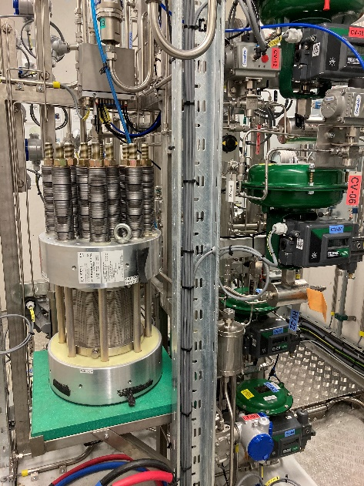In order to realize the potential of high-pressure water electrolysis it is crucial to have in-depth knowledge on design, construction and operation of such systems. Institute for Energy Technology (IFE) in Norway has designed and built a flexible PEMWE-system laboratory for testing of water electrolyzers up to 33 kW with hydrogen output pressures of a maximum of 200 bar. This system testing platform can be used to emulate duty cycles (e.g., grid load profiles, solar and/or wind generation), test hybrid system configurations of water electrolyzers and batteries, investigate the performance of differential pressure water electrolyzers at startup, shutdown and partial load operation, and to validate system models.

1. System Description
   1. **Stack**

Figure 1 depicts the prototype stack from Nel Hydrogen installed in the test rig. The stack is designed for hydrogen outlet pressures up to 350 bar (differential pressure operation). It has 34 cells connected in series, each with an active area of 86 cm2. The stack’s maximum operating current is 160 A, with a corresponding nominal stack voltage of 75 V (BOL) and a hydrogen production rate of 2 Nm3/h. The stack has been tested up to 350 bar by Nel Hydrogen but has since then been stored for three years prior to testing at IFE. It has been regularly attended and hydrated during those years.

Figure 1: Prototype 12 kW stack for hydrogen outlet pressures up to 350 bar (Nel Hydrogen).

## Control System

The key component for controlling and collecting the signal data from the PEMWE-test rig is a cRIO-controller from National Instruments, and the system is set up with a standalone LabVIEW RT application.

* + 1. *System monitoring*

The main front panel of the LabVIEW application, depicted in Figure 2, shows the full P&ID for the Balance of Plant (the details of which were presented at EFCF 2019 [3]). In this front panel all the installed instrument readings, as well as the valve settings, are visible. If any instrument goes into a warning or alarm state, the background of the numerical value field for the instrument will become yellow or red, respectively. In the example shown below there is a warning due to a too high conductivity of water (CC-01), as well as a too high stack water inlet pressure (PT-04). This front panel is only used for monitoring of the system; altering any settings must be done in the other tabs, such as the “O2 Side Water Temp Control” (see below). Please revert to Figure 2 to locate the various instruments (with tags) referred to in the subsequent chapters.

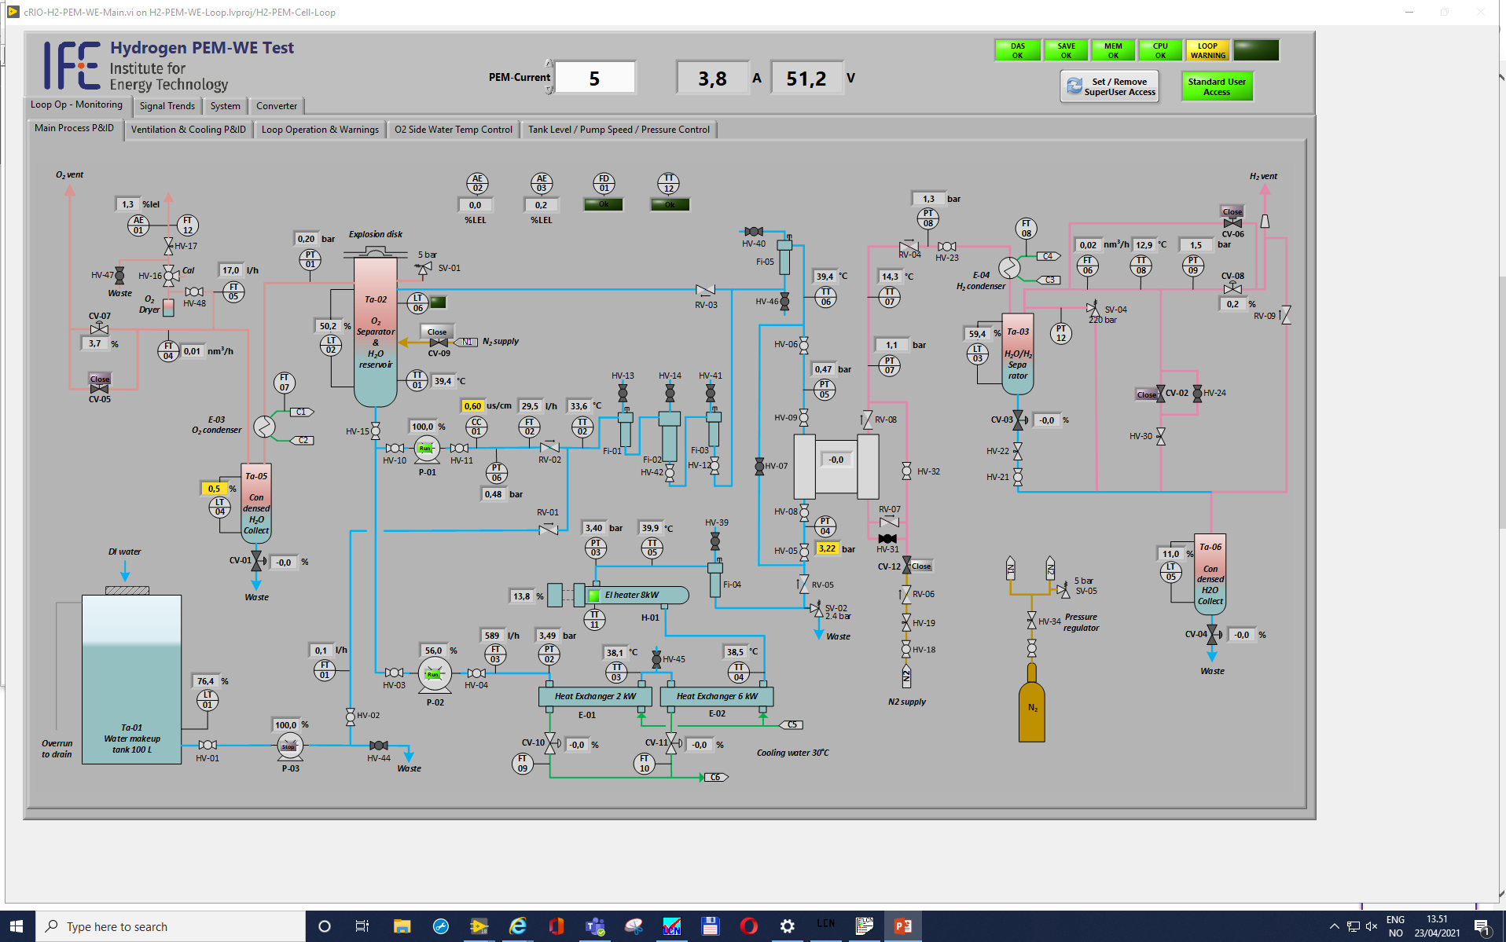

Figure 2: LabVIEW front panel showing the full P&ID for the system. All installed instrument readings are displayed, and warning or alarm states are indicated by yellow or red background colour.

* + 1. *Temperature Control*

As the PEMWE-stack generates heat, two heat exchangers (E-01 and E-02) with a heat removal capacity of 2 and 6 kWtherm, respectively, are installed in series in the main circulation loop. An electrical heater H-01 (8 kWel) is furthermore installed to heat the loop water to the desired temperature during startup, as well as to maintain the operating temperature at partial load operation (the system is uninsulated and will have significant heat losses).

Figure 3 shows the front panel which holds the detailed settings and indicators of the controllers working with the temperature control of the anodic loop. The system is set up as a cascade structure. Three heater/cooler power PID controllers are controlling the temperature measured directly close to the respective output water streams. PID parameters, output range and auto/manual settings can be altered for each of the controllers. For H-01, an additional interlock demanding a minimum flow for powering on is implemented for safety reasons. For valve opening outputs of the E-01 and E-02 controllers some additional gain and offset settings are made available for optional fine tuning the valve functionality. These inner PID controllers are set up for providing fast temperature response to any change of the setpoint.

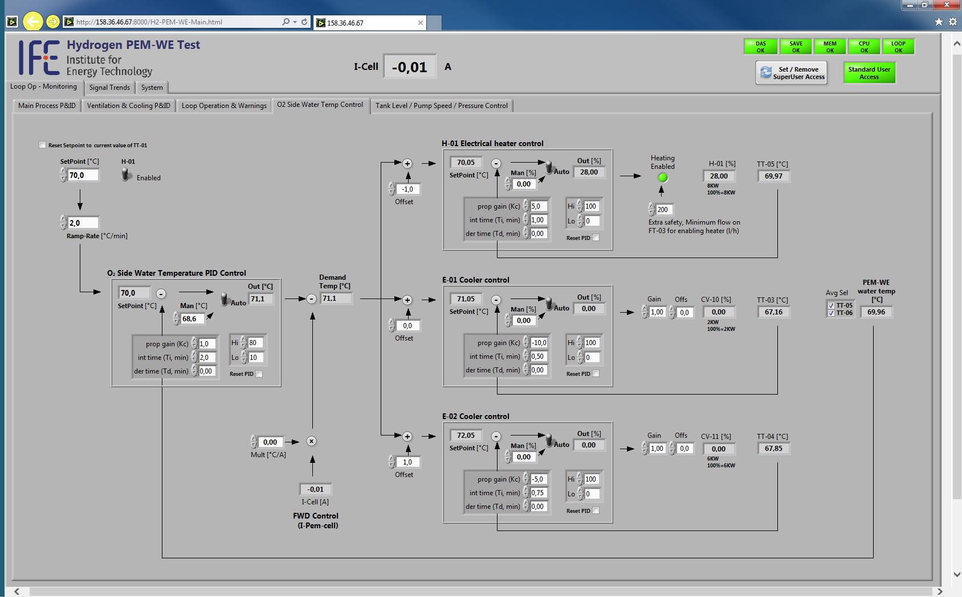

Figure 3: Front panel of the temperature control system which is set up as a cascade structure

The three inner controllers are tied together by means of an overall outer temperature PID controller. The temperature setpoints for the three inner PID controllers are offset in order to reduce and adjust the overlap between heating and cooling power. The setpoints of the inner power controllers may also be altered by a feed forward effect based on the applied stack load: When the heat generated by the stack at a certain load is known, it can be applied as a multiplying factor. This will improve the dynamic performance of the temperature control as it will not need to wait for the measured temperature feedback effect before an action is taken. The outer temperature PID controller is set up with relatively low gain but considerable integrating effect and will slowly make the average value of the temperature settle on target. A ramp rate limiter is also included for reducing overshoots if big steps are introduced in the setpoint setting.

* + 1. *Control flow diagram*

The control flow diagram for the WE-system is indicated in Figure 4 below. The system is always inertisized with N2 before startup and any unsolved alarms are reset. The automatic scheduled sequence “Loop startup” is initiated which starts the pumps and the ventilation, set control valves in default operating mode and check for alarms. If there is an alarm (such as a too high H2 sensor reading) the “loop shutdown” procedure is triggered which cuts the power to the stack, depressurizes the H2 subsystem and purges both the O2 and H2 sides. When the system has been purged and the water temperature is below 40 °C, the pumps and ventilation stops.



Figure 4: PEMWE system control flow diagram

## Power conditioning and cell voltage monitoring systems

The NFCH system laboratory will, when completed, include a 13 kW PEM fuel cell stack (Power Cell), a 20 kWh battery module and the herein described 12 kW PEMWE stack (Nel Hydrogen). Each of these key components have their own dedicated DC/DC-converter (Hot Platinum), which all are coupled to the same DC-bus. This makes it possible to test various electric topologies. The DC-bus is connected to the local grid via an AC/DC converter (Bitrode FTF 300-450) which can both provide energy to the bus (charge mode) and dissipate energy from the bus (discharge mode). Lead-acid batteries are included to keep the DC bus voltage stable at 150 VDC and the Bitrode is programmed to switch between charge and discharge mode based on voltage limits (e.g., discharge: Ubus ≥ 150.5 V and charge: Ubus ≤ 149.5 V).

In order to monitor the state of health of the individual cells and study the performance of cells at various locations in the stack, cell voltage monitoring (CVM) is required. By comparing individual cell voltages to the average, faulty cells can be detected, and catastrophic cell failures prevented. The installed CVM system (SMART TESTSOLUTIONS) consists of 46 modules with 10 channels per module and can provide a sampling rate of up to 1 kHz.

1. Commissioning and Baseline tests

In the following the results from the first preliminary stack tests are presented. The stack operating conditions are summarized in Table 1, listing the main test input and output parameters. The stack was operated in galvanostatic control. Temperatures were within ± 0.8 °C of target, pressures where within ± 2.4 bar of target. The water conductivity was in the range 0.3-0.5 µS/cm.

Table 1: Stack operating conditions with Test Input and Test Output Parameters

|  |  |  |  |  |
| --- | --- | --- | --- | --- |
|  | **Parameters** | **Unit** | **Values** | **Tag\*\*\*** |
| **TIPs** | H2 outlet pressure, PH2 (gauge) (set point) | barg | 10 and 30 | PT-09 |
| O2 outlet pressure, PO2 (gauge) (set point) | barg | 0.2 | PT-01 |
| H2O inlet pressure Pwater,in (gauge) | barg | 2.4 | PT-04 |
| H2O flow rate, Qv,water,in (oxygen evolution electrode)** | L/h | 420-600 | FT-03 |
| Stack temperature, Tc (set point)* | °C | 50 |  |
| Water outlet temperature Twater,out * | °C | 50 | TT-06 |
| Water inlet temperature, *Twater,in* * | °C | 45-50 | TT-05 |
| Stack current, *I* | A | 10-125 |  |
| **TOPs** | Stack voltage, *U* | V | 52-69 |  |
| H2 outlet pressure | barg | ≤ 30 | PT-09 |
| O2 outlet pressure | barg | 0.2 | PT-01 |
| H2 outlet temperature | °C | ≤ 40 | TT-07 |

*The stack temperature setpoint (*Tc*) is measured directly at the stack water outlet *Twater,out.* The stack water outlet temperature set point *Twater,out* was regulated by the variation of the stack water inlet temperature, and *Twater,out*is thus considered a static TIP, while *Twater,in* is a variable TIP

**The water pump speed was kept constant during the test, causing the water inlet flow rate to vary with resistance/pressure drop over the stack. At high current densities there was a need to reduce the pump speed in order to not exceed the maximum allowable water inlet pressure of 2.4 bar.

*** c.f. Figure 2.

* 1. Current sweep and polarization curves

The polarization curve measurements were performed with a stepwise steady-state current sweep applying consecutive current density steps according to ref. [4]. The dwell time and data acquisition time were minimum 30 s each (the current sweep was manually controlled, and the dwell time therefore varied from step to step). Only the ascending polarization curves were recorded. The control accuracy was ± 0.2 % for the lowest current density and improved with increasing current.

The stack current and voltage recorded during a current sweep at 50 °C and 30 barH2 is plotted as a function of time in Figure 5. For safety reasons, full turndown is not possible at a H2 pressure of 30 bar, and the polarization was therefore recorded from 30 A (corresponding to a current density of 0.35 A/cm2) up to 125 A (1.5 A/cm2). The test was aborted before the maximum operating current of 160 A was reached because the gas evolution on the anode increased the resistance to water flow, making it impossible to maintain a sufficiently high water flow rate (>600 L/h) meanwhile keeping the water inlet pressure below the rated maximum (2.4 bar). The setup has therefore, after this test, been adjusted to reduce the stack water inlet pressure (*Pwater,in*).

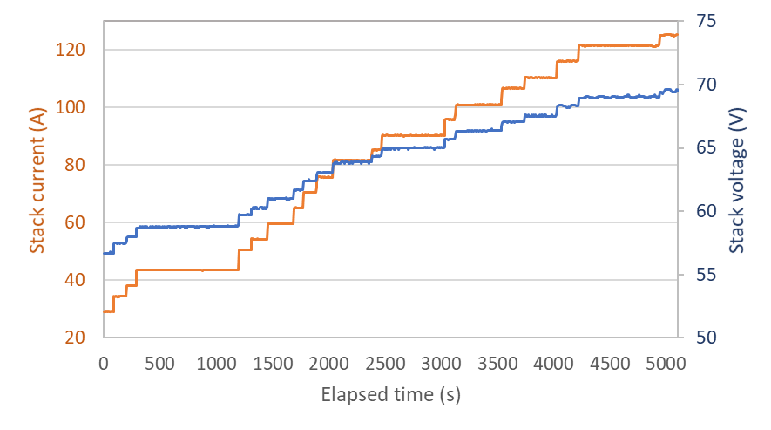

Figure 5: Stack current and voltage recorded during ascending current sweep at 50 °C and 30 barH2

In Figure 6, the IV-curve recorded at 30 barH2 is plotted together with the stack polarization at 10 barH2 and 350 barH2 (the latter provided by Nel Hydrogen, recorded prior to the idle period at IFE). For the polarization curves measured at IFE, the stack current and voltage has been averaged over 10 data points recorded during the period of data acquisition at each current density step. The increase in stack polarization with increasing H2 outlet pressures is as expected and can be understood by the unfavourable thermodynamics of electrochemical gas compression (Nernst relation).

Due to the very high endplate sealing load of the stack (c.f. Figure 1 showing the thick endplates and the long tie rods with numerous spring washers) it was concerning that the stack had been sitting idle (“on the shelf”) without internal pressurization for such a long time. This could have caused performance deterioration and, in the worst case, severe degradation of cell components leading to premature cell failure. It was therefore encouraging that the stack polarization was in the expected range and that all the cells displayed approximately the same voltages (the CVM data will be presented in a separate publication). The concentration of H2 in the O2 stream (not shown here) was furthermore stable at 7-8 % of LEL (corresponding to ~ 0,3 vol% H2) during the tests, which is another indication that the cells and seals were intact and had withstood the high sealing load during the idle period.

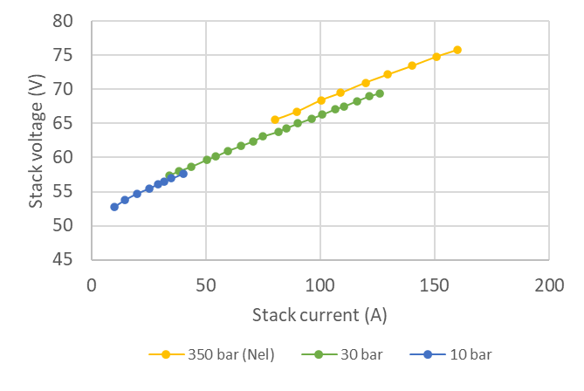

Figure 6: Stack polarization curves recorded at three different H2 outlet pressures.

* 1. H2 pressure control

The hydrogen pressure is controlled by the back-pressure regulator *CV-08* (setting the upstream pressure with a spring) with the use of pressure transmitter *PT-09*. Figure 7 shows the recorded H2 pressure, H2 flow, and the regulator valve opening at a DC current of 44 A (corresponding to a H2 production rate of 0.56 Nm3/h). The plot, representing a time period of approximately 12 minutes, demonstrates that the installed back-pressure regulator has a too large Cv for partial load operation and is therefore unable to maintain a stable pressure and gas flow: At approximately 13 % valve opening, the H2 flow is seen to increas abruptly and the pressure drops to approximately 27 bar before the valve closes again. This results in a fluctuating cathodic pressure and a pulsed release of H2 which, respectively, introduces unwarranted mechanical stress and renders the monitoring of H2 production rate very challenging.

The resulting pressure control accuracy of ± 8 % is an order of magnitude lower than the recommended accuracy (± 0.8 %) [4], and will worsen with increasing pressure drop over the regulator. It was therefore decided to implement an alternative back-pressure regulator technology which is better suited for small flow rates and which controls the upstream pressure using a diaphragm (*Pressure Control Solutions B.V.*).

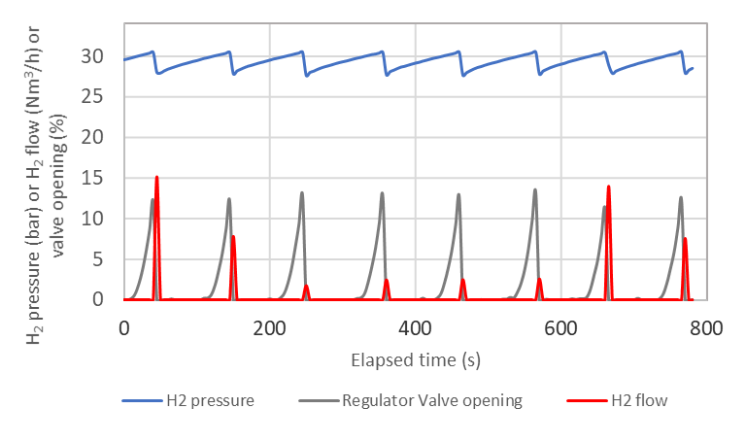

Figure 7: H2 pressure, back pressure regulator opening, and H2 flow at 44 A over the course of 12 min.

* 1. Water Management

The system has two main gas/water separators, one for oxygen/water separation (*Ta-02*) and one for hydrogen/water separation (*Ta-03*). A makeup water pump (*P-03*) replenishes the water consumed in the electrolysis process upon a signal from a level transmitter in *Ta-02*. The control system aims to keep a constant level in this separator, but when the water consumption is below the minimum capacity of the pump it will be necessary to switch to dead band (on/off) control. On the H2 side, a heat exchanger is mounted upstream of *Ta-03* to enhance water removal from the hydrogen gas stream. The separator is drained via a control valve (*CV-03*) upon a signal from a point level transmitter, and the separated water is collected in a second tank at ambient pressure.

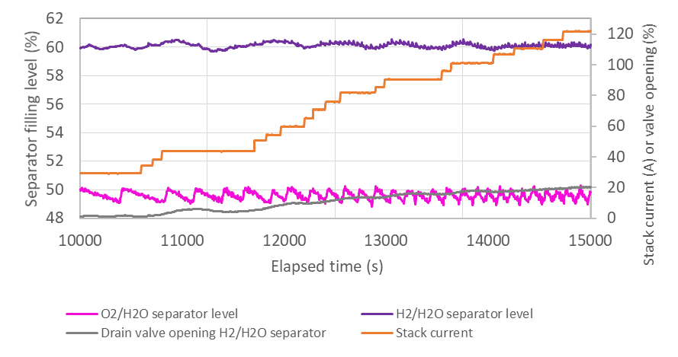

Figure 8: Gas/water separator levels, opening of drain valve H2/H2O separator, and stack current.

The plot in Figure 8 shows the filling level of the two gas/water separators and the opening of the drain valve *CV-03* (on the outlet of the hydrogen/water separator) during the current sweep at 30 barH2. The filling level set point of the oxygen/water and hydrogen/water separators are 50 % and 60 %, respectively. The plot shows that when the water level in *Ta-02* reaches approximately 49%, it is refilled to 50 % (by makeup pump *P-03*). The water replenishment frequency can be observed to increase with increasing current density. This is both because more water is electrolyzed at higher current densities, and because more water is transported across the membrane by electro osmotic drag.

The water drag can be determined with the current setup by logging the water levels, keeping track of the batch-wise release of water, and assuming the fluid exiting the separators is single phase with 100 % RH. By way of example, At 44 ADC the water level in *Ta-03* drops from 50 % to 49 % (corresponding to a water consumption of approximately 0.3 L) over a time period of 4.2 min. 0.03 L water is electrolyzed in this time step, and the remaining water consumption of 0.27 L corresponds to a water drag of 8,5 mol H2O/mol H2.

## Thermal Management

The righthand y-axis in Figure 9 depicts the applied heater power and the cooling exerted by the heat exchangers, while the lefthand y-axis depicts the stack water inlet and outlet temperature (*Twater,in*and *Twater,out*, respectively), and the H2 outlet temperature (*TH2,out*) during system startup (inset) and during the current sweep at 30 barH2 and 50 °C.

Initially the temperature setpoint is below the actual system temperature of 15 °C, and the maximum heat removal rate of 8 kWtherm (2+6) is thus applied. The inset shows that when the setpoint is changed to 50 °C, the flow through the coolers is immediately choked and the heater power increases to approximately 5 kWel. The system uses 17 minutes to reach a water outlet temperature of 49 °C, and the temperature is subsequently finetuned and regulated from 49 to 50 °C the next 9 minutes.

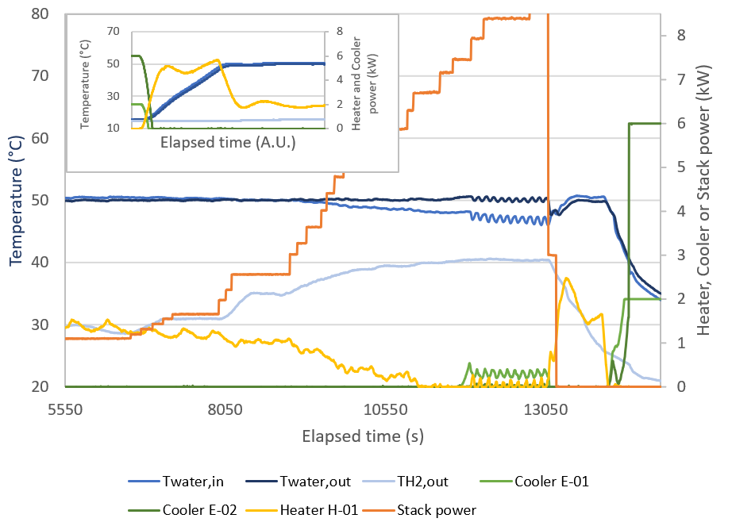

Figure 9: Stack power, heating and cooling power demand, stack water inlet and outlet temperature, and H2 outlet temperature during a current sweep at 30 barH2 and 50 °C. The inset shows the temperature during system start-up

The main plot in Figure 9 shows how the heating and cooling demand changes with increasing stack power at a constant temperature setpoint of 50 °C. The external heating demand decreases with increasing stack power due to the increased heat generation by the stack itself (with energy efficiency of approximately 67 % (HHV)). At a stack power of 6.7 kWel, the system temperature is self-sustained and neither external heating nor active cooling is required. When the stack power exceeds 8 kWel, the regulator starts alternating between cooling via E-01 and heating, and the water temperature as a result starts to fluctuate (± 0.8 K). This shows the need to fine-tune the PID controllers and associated cascade structure even further.

It should be noted that *Twater,out* remains relatively stable at 50 °C throughout the test, while *Twater,in* decreases and deviates gradually more from this value. This is because the stack outlet temperature *set point* is regulated by the variation of the stack water inlet temperature. At the highest measured stack power of 8.9 kW, the temperature difference across the stack (ΔT) is approximately 4 °C.

The H2 outlet temperature, *TH2,out*, is largely governed by the humidity of the produced gas, which in turn is determined by the magnitude of the electro osmotic drag. The gradual increase in cathodic outlet temperature with increasing current density is therefore as expected.

**Summary**

A flexible PEMWE system platform for testing of high-pressure stacks (≤ 200 barH2) has been installed at Institute for Energy Technology (IFE). The test rig is integrated with a sophisticated power conditioning system which makes it possible to test hybrid electric topologies for the water electrolyzer system. The control system has a high funct­ionality and is designed for in-depth studies of system performances and for tailoring and testing of control strategies which safeguards the system and maximizes efficiency and durability.

The test rig has been commissioned with a prototype stack from Nel Hydrogen. In this contribution, polarization curves and associated system data recorded at 10 and 30 barH2 is presented. The baseline tests show that the stack has preserved its performance while being stored at IFE, and that the water conditioning system has been properly designed and tuned to maintain the required water quality, temperature, and levels during a current sweep. The numerous temperature sensors in the test rig, together with accurate measurements of e.g., water levels and flowrates, makes the system ideal for validating detailed PEMWE process models.

**Acknowledgements**

This work was carried out within the *Norwegian Fuel Cell and Hydrogen Centre* (project no. 245678), and *MoZEES*, a Norwegian Centre for Environment-friendly Energy Research (FME), co-sponsored by the Research Council of Norway (project number 257653) and 40 partners from research, industry and public sector.

References

1. Grigoriev, S.A., et al., *Current status, research trends, and challenges in water electrolysis science and technology*. International Journal of Hydrogen Energy, 2020. 45(49): p. 26036-26058.

2. European Commission, A Hydrogen Strategy for a climate-neutral Europe, 2020

3. Hancke, R, et al., *High Differential Pressure PEMWE System Laboratory*. EFCF 2019 Low-Temperature Fuel Cells, Electrolysers & H2 Processing (<http://hdl.handle.net/11250/2619446>).

4. Malkow, T, et al., *EU harmonised polarisation curve test method for low-temperature water electrolysis,* 2018. ISBN: 978-92-79-81993-3

*Keywords: EFCF2021, H2, LowTemp. Fuel Cells & Electrolysers, Flexible PEMWE system test rig, high-pressure stacks (≤ 200 barH2 and 33 kW)*